FLASCA Menu: Term 4, Week 1
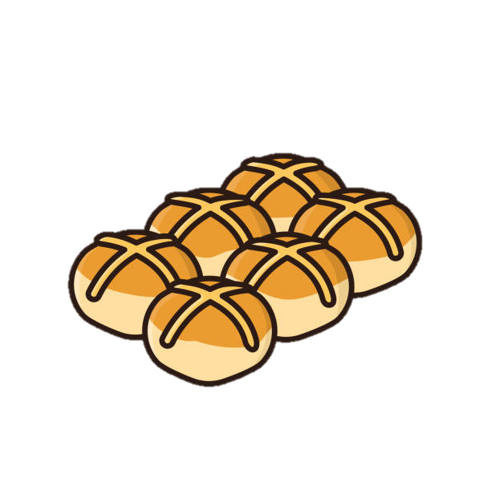
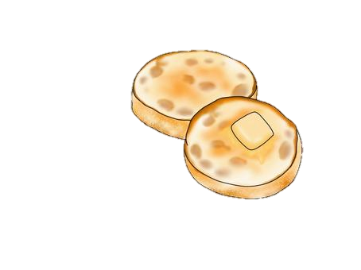


Breakfast:
Monday | Tuesday | Wednesday | Thursday | Friday
Toast with Jam, Honey, Vegemite, Butter  selection of cereals    Fruit Smoothies | Toast with Jam, Honey, Vegemite, Butter  selection of cereals  English Muffins | Toast with Jam, Honey, Vegemite, Butter  selection of cereals  Fruit Smoothies | Toast with Jam, Honey, Vegemite, Butter  selection of cereals  Hot Cross Buns | Toast with Jam, Honey, Vegemite, Butter  A selection of cereals  Waffles or pancakes


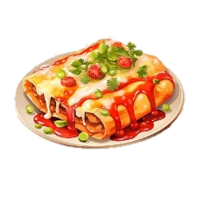
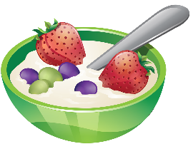
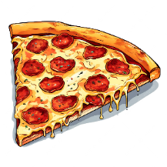

c Afternoon Tea:
Monday – LAST DAY OF V.A.C | Tuesday | Wednesday | Thursday | Friday
Ham & Cheese Rolls  *Fresh fruit and veggies on the side*  - Tortilla wraps  - Filling (Ham, cheese, cream cheese  - Veggies (carrots and cucumber)  Vegetarian & Gluten free options available | Pizza  *Fresh fruit on the side*  - Pizza bases  - Pizza sauce  - Toppings (pepperoni, cheese, & Italian herb seasoning)  Vegetarian & gluten free options available | Yogurt Bowls  *Fresh fruit on the side*  - Yogurt – strawberry, vanilla, peach & mango, coconut  - Nut-free granola  Dairy free & gluten free options available | Enchiladas  *Fresh fruit on the side*  - Tortilla wraps  - Cheese  - Minced beef  - Taco seasoning  - Corn salsa  - Passata  Gluten free & dairy free options available | Kebabs  *Fresh fruit on the side*  - Kebab (Chicken and lamb)  - Tzatziki sauce  - Pita bread  - Veggies (Pepper, tomatoes, and onions)  Gluten free & vegetarian options available

Cheese & Crackers
Trail Mix
Cruskits
Trail Mix
Trail Mix

