FLASCA WEEKLY NEWSLETTER
Term 2, Week 9: 15th of June – 19th of June

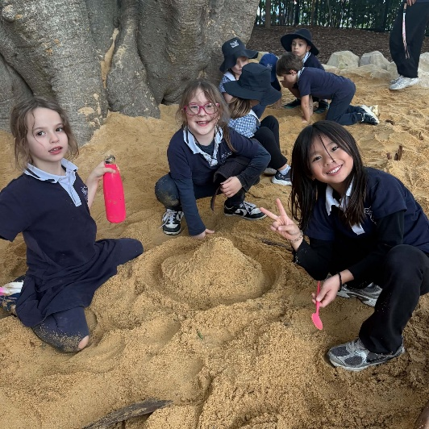
Hi Families,
Welcome to Week 9 at FLASCA! We had another exciting week filled with creativity, connection, and plenty of fun experiences for the children. The children continued to enjoy our new playground, exploring the sandpit, building friendships, and engaging in imaginative play. Throughout the week, children participated in a range of activities including arts and crafts, games, and group experiences that encouraged teamwork, confidence, creativity, and problem-solving skills.
As we move closer towards the end of the term, we have loved seeing the children continue to build relationships, share their ideas, and make the most of their time at FLASCA.



Next Week’s Menu
Monday: Chicken Burrito Bowls
Tuesday: Tacos
Wednesday: Yogurt Bowls
Thursday: Sloppy Joes
Friday: Veggie Pad See Ew
PROGRAM
Throughout Week 9, children enjoyed a range of engaging experiences at FLASCA, including lots of fun and excitement with our FLASCA blue wig! On Monday, children explored creativity and problem-solving through the DIY Rainbow Spinner, LEGO Animal Challenge, Mud Kitchen, Penalty Shootouts, and Ribbon Dancing, encouraging imagination, teamwork, and self-expression. On Tuesday, children participated in STEM Club with the Baking Soda Volcano Experiment, Stop Motion Club Claymation, and Knockout, developing curiosity, collaboration, and physical skills. On Wednesday, children enjoyed Shaving Cream Art, Base Building, and Gymnastics with a Handball Tournament, supporting creativity, communication, and confidence. On Thursday, children took part in World Cup Jersey Origami, Educators vs Children Soccer Match, Reading Corner, and Capture the Flag, building social connections, teamwork, and sportsmanship. On Friday, children finished the week with Stuck in the Mud and Cooking Club Apple Cinnamon Muffins, where they developed coordination, cooperation, and practical skills while having fun together. Across the week, children continued to build friendships, share ideas, and create memorable experiences through play, exploration, and child-led activities.

FEEDBACK/UPDATES

Vegetarian, GF and DF options available

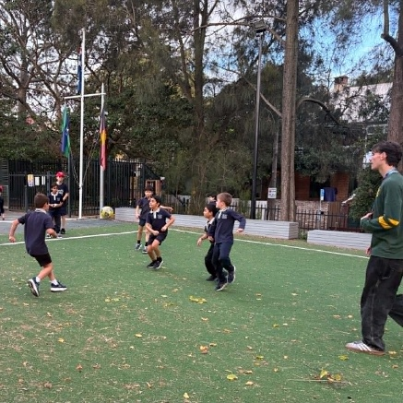
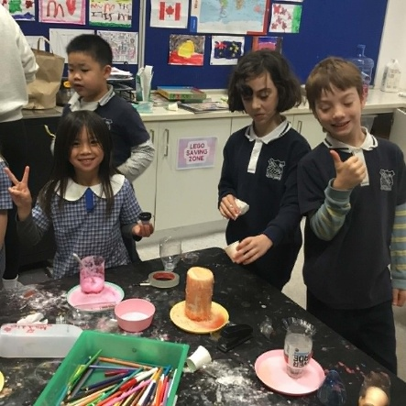
Please ensure you complete and sign the authorisation forms for Vacation Care if your child is attending. These forms are required for children to leave school grounds for excursions and activities. They are available through your email or from the FLASCA office!
As the weather is becoming cooler but the UV levels can still be high, we kindly ask families to ensure children bring a sun safe hat to FLASCA each day. Hats are important for outdoor play and activities.

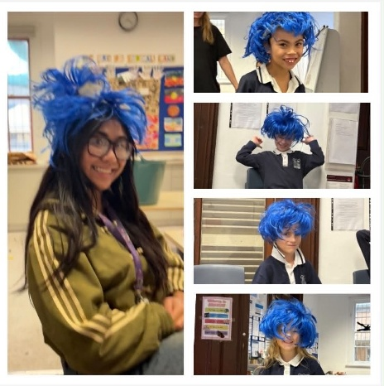
CHILDREN’S COMMMENTS
“This volcano is awesome!”
“This wig looks so funny on my head”

