FLASCA WEEKLY NEWSLETTER
Term 2, Week 10: 29th of June – 3rd of July

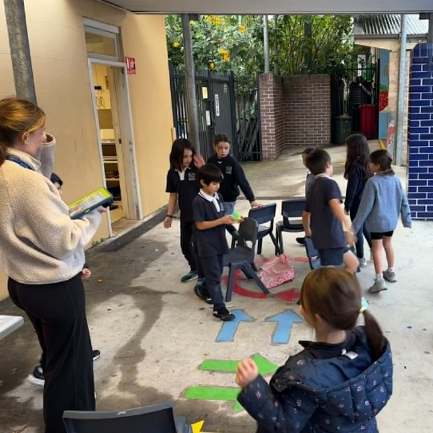
Hi Families,
Welcome to Week 10 at FLASCA!
Despite the wet and chilly weather, the children have continued to have an amazing time at FLASCA. The rain and cold haven’t slowed us down, with plenty of indoor games, creative activities, and fun group experiences keeping everyone busy and engaged. Whenever the weather has allowed, we’ve also made the most of outdoor play, showing great resilience and enthusiasm in all conditions. It’s been a fantastic week full of energy, laughter, and teamwork as we head toward the end of term.



Next Week’s Menu
Monday: Spaghetti & Meatballs
Tuesday: Yogurt Bowls
Wednesday: Butter Chicken & Rice
Thursday: Chicken Skewers & Pita Bread
Friday: Spinach & Ricotta Triangles
PROGRAM
Across the week at FLASCA, children engaged in a wide range of creative, physical, and hands-on experiences. Monday included DIY stress balls, base building in the grass area, and Dance Club. Tuesday featured a LEGO Challenge, stop-motion filming, and a Colour Run. Wednesday included paper chain decorations, an Educator vs Children soccer match, and STEM bath bomb experiments. Thursday involved kaleidocycles, Musical Chairs, and Yoga & Horse movement activities children also due to wet weather we enjoyed watching A Minecraft Movie as a calm, shared indoor experience. Friday finished with finger painting, Cops & Robbers, and Cooking Club making vegetable and cheese scones. These activities supported children’s development in fine and gross motor skills, problem-solving, teamwork, communication, and scientific thinking while encouraging creativity, self-expression, and resilience. Throughout the week, children also built confidence, strengthened social connections, and practised emotional regulation through both high-energy group games and calm, choice-based downtime activities.

FEEDBACK/UPDATES

Vegetarian, GF and DF options available

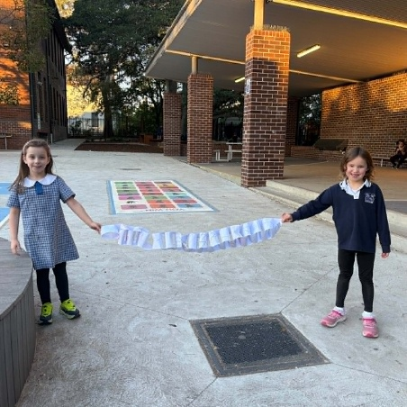
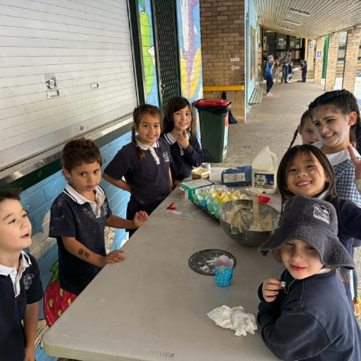
FLASCA will be hosting a special End of Term party this Thursday during ASC to celebrate a fantastic term of learning, friendship, and fun. Children will enjoy an afternoon filled with exciting games, prizes, and celebration activities alongside their friends and educators. A variety of party finger foods and snacks will be provided for the children to enjoy throughout the session. It will be a fun and memorable way to finish the term together at FLASCA! See below for the invitation!
Vacation Care is just around the corner at FLASCA! Don’t miss out on a fun-filled program packed with exciting activities, games, and experiences for the school holidays. Book your child in now to secure their spot and make sure they don’t miss out on all the action and adventure we have planned!

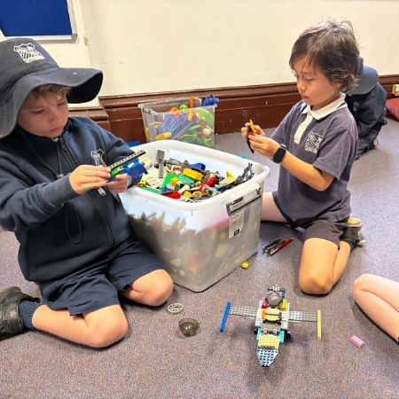
CHILDREN’S COMMMENTS
“I love the Minecraft movie so much!”
“Musical chairs is my favourite game”
