 | MONDAY | TUESDAY | WEDNESDAY | THURSDAY | FRIDAY
INDOORS (3:15PM – 5:00PM) | 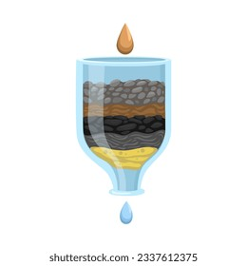  ACTIVITY: STEM Club: Water Filtration | ACTIVITY: Arts & Craft Club: Tissue Paper-Stained Glass  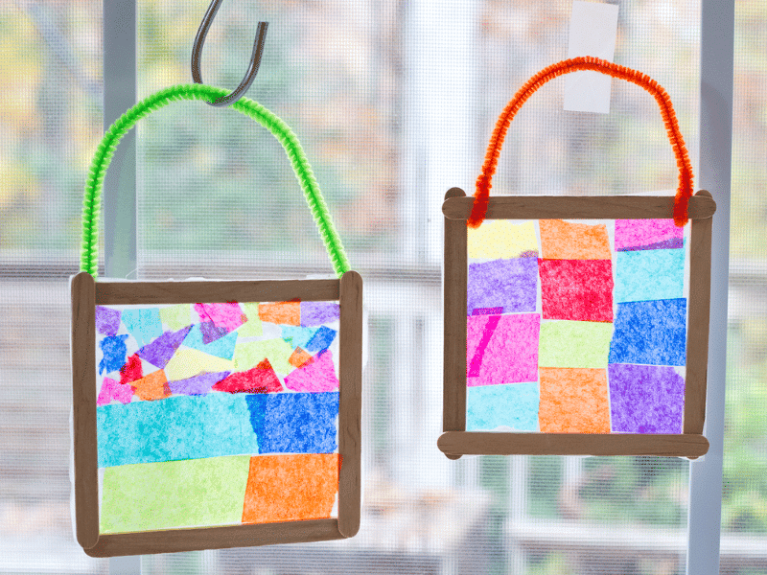 | 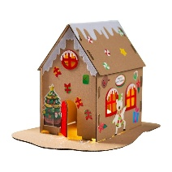  ACTIVITY: DIY Xmas Carton House |   ACTIVITY: Letter to Santa | 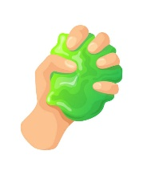  ACTIVITY: DIY Slime (suggested by Jymarah)
GRASS (3:15PM – 5:00PM) |     ACTIVITY: Soccer+ Reading Corner. | ACTIVITY: Capture the flag  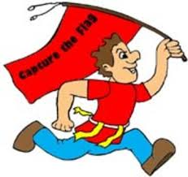 |   ACTIVITY: Children Council Meeting + Scramble (suggested by James E.)  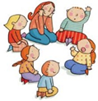 | 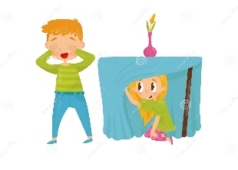  ACTIVITY: Food and Water (Maia T.) | ACTIVITY: Base Building + Soccer  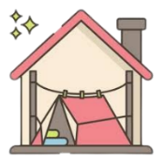
BBALL COURT (3.15-5.00PM | ACTIVITY: Beep Test + One Bounce (suggested by Tomas T.)     |   ACTIVITY: Cooking Activity: Potatoes Carrots Tortillas (suggested by Marco) + Basketball  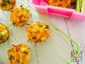 | 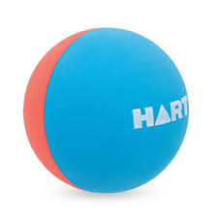  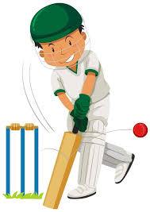  ACTIVITY: Handball + Cricket |   ACTIVITY: Performing Arts Club: Character Switch | ACTIVITY: Cooking Club: Rice Paper Rolls  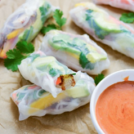
CLUB (3:15PM – 5:00PM) | STEM Club   | Arts & Craft Club  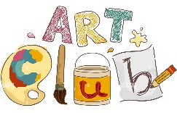 | FLASCA Children’s Council Meeting  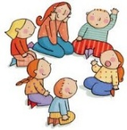 |   Performing Arts Club | Cooking Club  
EVENING (5:00PM – 6:00PM) |   ACTIVITY: CHILDREN’S CHOICE |   ACTIVITY: CHILDREN’S CHOICE | ACTIVITY: CHILDREN’S CHOICE  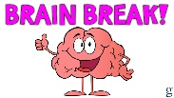 |   ACTIVITY: CHILDREN’S CHOICE | ACTIVITY: CHILDREN’S CHOICE

FLASCA AFTER SCHOOL PROGRAM: TERM 4 WEEK 8

