FLASCA Menu: Term 4, Week 4


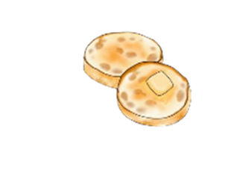

Breakfast:
Monday | Tuesday | Wednesday | Thursday | Friday
Toast with Jam, Honey, Vegemite, Butter  A selection of cereals  Oatmeal Berry Bowls | Toast with Jam, Honey, Vegemite, Butter  A selection of cereals  Fruit Smoothies | Toast with Jam, Honey, Vegemite, Butter  A selection of cereals  English Muffins | Toast with a either Jam, Honey, Vegemite, Butter  A selection of cereals  Fruit Smoothies | Toast with a either Jam, Honey, Vegemite, Butter  A selection of cereals  Waffles


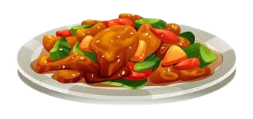
Afternoon Tea:
Monday | Tuesday | Wednesday | Thursday | Friday
Broccoli Mac and Cheese  *Fresh fruit on the side*  - Macaroni pasta  - Broccoli  - Roux (Milk, butter, flour)  - Cheese  - Taco seasoning  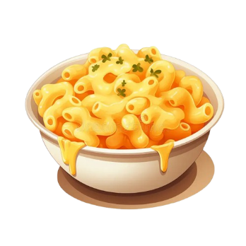  Vegetarian & Gluten Free options available | Enchiladas  *Fresh fruit on the side*  - Mince beef or beans  - Tortillas  - Cheese  - Passata  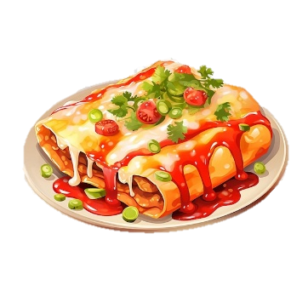  Vegetarian, Dairy Free & Gluten Free options available | Yogurt Bowls  *Fresh fruit on the side*  - Vanilla, strawberry, blueberry and mango yogurt  - Nut-free granola  Vegetarian & Gluten Free options available | Sausage Sizzle  *Fresh fruit on the side*  - Beef or vegan sausages  - Bread  - Onion  - Sauces    Vegetarian & Gluten Free options available | Teriyaki Chicken, Vegetables and Rice  *Fresh fruit on the side*  - Teriyaki marinade  - Chicken  - Veggies  - Rice  Dairy Free & Gluten Free options available

Trail Mix Cruskits Cheese & Crackers Trail Mix Cruskits

