FLASCA Menu: Term 4 Week 6

Breakfast:
Monday | Tuesday | Wednesday | Thursday | Friday
Toast with Jam, Honey, Vegemite, Butter  A selection of cereals    Fruit Smoothies | Toast with Jam, Honey, Vegemite, Butter  A selection of cereals  Oatmeal Bowls | Toast with Jam, Honey, Vegemite, Butter  A selection of cereals  Fruit Smoothies | Toast with a either Jam, Honey, Vegemite, Butter  A selection of cereals  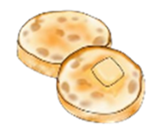  English Muffins | Toast with a either Jam, Honey, Vegemite, Butter  A selection of cereals    Pancakes

Afternoon Tea:
Monday | Tuesday | Wednesday | Thursday | Friday
Pizza Scrolls  (Suggested by Laila G.)  *Fresh fruit and veggies on the side*  - Puff pastry  - Pizza sauce  - Cheese  - Pepperoni or veggies (onions and capsicum)    Vegetarian, Dairy Free & Gluten Free options available | Sushi Bowls  (Suggested by Ethan S.)  *Fresh fruit on the side*  - Rice  - Tuna or chicken  - Veggies (Avocado, cucumber and carrots)  - Soy sauce and/or vegan mayo)  - Nori  Vegetarian, Dairy Free & Gluten Free options available  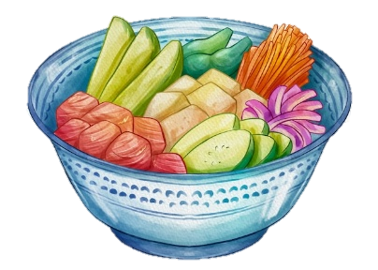 | Yogurt Bowls  *Fresh fruit and veggies on the side*  - Vanilla, strawberry, blueberry and mango yogurt  - Nut-free granola    Vegetarian, Dairy Free & Gluten Free options available | Chicken Alfredo with Garlic Bread  (Suggested by Jensen C.)  *Fresh fruit and veggies on the side*  - Chicken  - Alfredo sauce  - Pasta  - Garlic Bread  - Cheese  Vegetarian, Dairy Free & Gluten Free options available  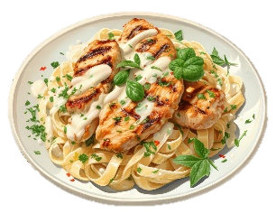 | Butter Chicken and Rice  (Suggested by Henry N.)  *Fresh fruit on the side*  - Chicken  - Butter chicken sauce  - Rice  Vegetarian & Gluten Free options available  

Trail Mix Cruskits Cheese & Crackers Trail Mix Cruskits

