FLASCA Menu: Term 4 Week 7

Breakfast:
Monday | Tuesday | Wednesday | Thursday | Friday
Toast with Jam, Honey, Vegemite, Butter  A selection of cereals    Fruit Smoothies | Toast with Jam, Honey, Vegemite, Butter  A selection of cereals  Oatmeal Bowls | Toast with Jam, Honey, Vegemite, Butter  A selection of cereals  Fruit Smoothies | Toast with a either Jam, Honey, Vegemite, Butter  A selection of cereals  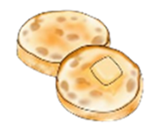  English Muffins | Toast with a either Jam, Honey, Vegemite, Butter  A selection of cereals    Pancakes


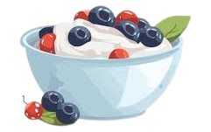
Afternoon Tea:
Monday | Tuesday | Wednesday | Thursday | Friday
Kebabs & Pita Bread  (Suggested by Liam S.)  *Fresh fruit and veggies on the side*  - Chicken/lamb or roasted veggie (capsicum and onions) kebabs  - Pita bread  - Tzatziki Dip  Vegetarian, Dairy Free & Gluten Free options available  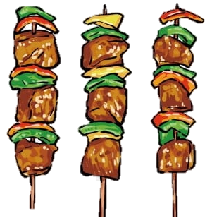 | Yogurt Bowls  *Fresh fruit on the side*  - Vanilla, strawberry, blueberry and mango yogurt  - Nut-free granola  Vegetarian, Dairy Free & Gluten Free options available | Spaghetti Bolognese  (Suggested by Crisse C.)  *Fresh fruit and veggies on the side*  - Spaghetti  - Minced beef  - Passata  - Onions  - Italian herb seasoning  - Cheese  Vegetarian, Dairy Free & Gluten Free options available  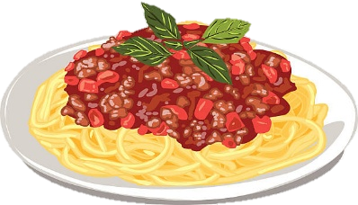 | Thanksgiving Cornbread and Roasted Veggies  (Suggested by Demi W.)  *Fresh fruit and veggies on the side*  - Veggies (Carrots and pumpkin)  - Honey  - Cornmeal, flour, sugar, creamed corn, butter and milk  Dairy Free & Gluten Free options available   | Fairy Bread & Veggies Sticks  (Suggested by Anna S.)  *Fresh fruit on the side*  - Bread  - Dairy free butter  - Sprinkles  - Veggies (Carrots, cucumbers, and capsicum)  Vegetarian & Gluten Free options available
Cheese & Crackers
Trail Mix
Trail Mix
Cruskits
Fruit

