
FLASCA AFTER SCHOOL PROGRAM: TERM 1 WEEK 2
 | MONDAY | TUESDAY | WEDNESDAY | THURSDAY | FRIDAY
INDOORS (3:15PM – 5:00PM) |   ACTIVITY: DIY BOOKMARKS |   ACTIVITY: EGG DROP CHALLENGE | ACTIVITY: SPONGE PAINTING  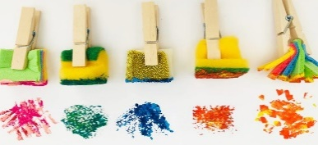 | 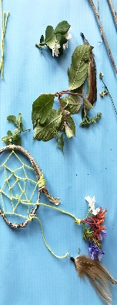  ACTIVITY: NATURE DREAMCATCHERS | ACTIVITY: ORIGAMI ANIMALS  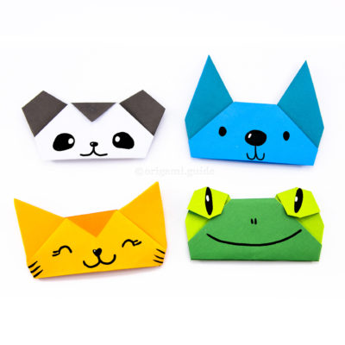
GRASS (3:15PM – 5:00PM) |   ACTIVITY: CAPTURE THE FLAG |   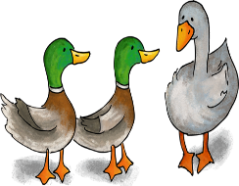  ACTIVITY: DUCK, DUCK, GOOSE & MUD KITCHEN |     ACTIVITY: SOCCER & DRAWING OUTSIDE |   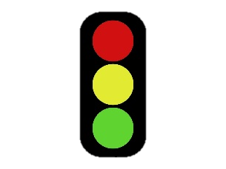  ACTIVITY: RED LIGHT GREEN LIGHT |   ACTIVITY: SOCCER & MUSICAL CHAIRS
BBALL COURT (3.15-5.00PM |   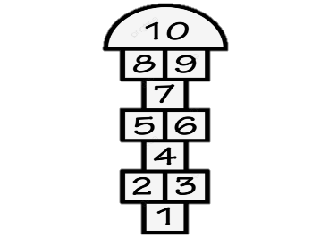  ACTIVITY: BEEP TEST & CHALK DRAWING HOPSCOTCH |       ACTIVITY: MARSHMELLOW & TOOTHPICK ENGINEERING & JUMPING SCIENCE |     ACTIVITY: RELAY RACES & LEGO MASTERS |   CTIVITY: GYMNASTICS & BASKETBALL   | 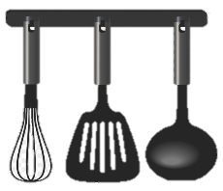    ACTIVITY: COOKING CLUB
CLUB (3:15PM – 5:00PM) | ACTIVITY: TO BE DECIDED   | ACTIVITY: TO BE DECIDED | ACTIVITY: TO BE DECIDED | ACTIVITY: TO BE DECIDED |   ACTIVITY: COOKING CLUB
EVENING (5:00PM – 6:00PM) |   ACTIVITY: CHILDREN’S CHOICE | ACTIVITY: CHILDREN’S CHOICE   |   ACTIVITY: CHILDREN’S CHOICE |   ACTIVITY: CHILDREN’S CHOICE | ACTIVITY: CHILDREN’S CHOICE

