FLASCA Menu: Term 4 Week 8

Breakfast:
Monday | Tuesday | Wednesday | Thursday | Friday
Toast with Jam, Honey, Vegemite, Butter  A selection of cereals    Fruit Smoothies | Toast with Jam, Honey, Vegemite, Butter  A selection of cereals  Oatmeal Bowls | Toast with Jam, Honey, Vegemite, Butter  A selection of cereals  Fruit Smoothies | Toast with a either Jam, Honey, Vegemite, Butter  A selection of cereals  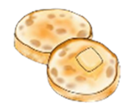  English Muffins | Toast with a either Jam, Honey, Vegemite, Butter  A selection of cereals    Pancakes

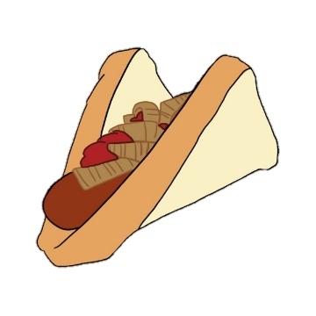
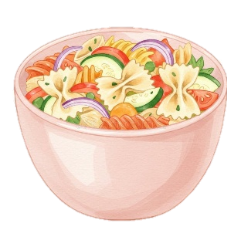
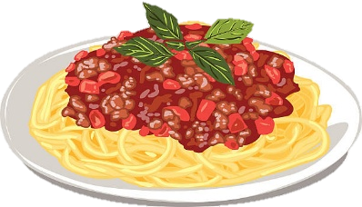

Afternoon Tea:
Monday | Tuesday | Wednesday | Thursday | Friday
Sausage Sizzle  (suggested Joshua T.)  *Fresh fruit on the side*  - Sausages  - Onion  - Bread  - Ketchup, mustard  Vegetarian & Gluten Free options available | Butter Chicken  (Suggested Tala M.)  *Fresh fruit on the side*  - Chicken  - Rice  - Butter Chicken Sauce  - Frozen Veggies    Vegetarian, Dairy Free & Gluten Free options available | Yogurt Bowls  *Fresh fruit on the side*  - Vanilla, strawberry, blueberry and mango yogurt  - Nut-free granola  Vegetarian, Dairy Free & Gluten Free options available | Spaghetti Bolognese  (Suggested by Ellinor A.)  *Fresh fruit on the side*  - Ground Beef  - Passata  - Spaghetti  - Frozen Veggies  Vegetarian, Dairy Free & Gluten Free options available | Salad Pasta + Garlic Bread  (Suggested by Marco P.)  *Fresh fruit on the side*  - Pasta Bow Tie  - Tomatoes  - Red Capsicums  - Purple Onion  - Cheese  - Garlic Bread  Vegetarian, Dairy Free & Gluten Free options available
Cheese & Crackers
Trail Mix
Trail Mix
Cruskits
Fruit

