FLASCA BEFORE SCHOOL PROGRAM: TERM 4 WEEK 2
OUTCOME 1: CHILDREN HAVE A STRONG SENSE OF IDENTITY
OUTCOME 2: CHILDREN ARE CONNECTED WITH AND CONTRIBUTE TO THEIR WORLD
OUTCOME 3: CHILDREN HAVE A STRONG SENSE OF WELLBEING
OUTCOME 4: CHILDREN ARE CONFIDENT AND INVOLVED LEARNERS
OUTCOME 5: CHILDREN ARE EFFECTIVE COMMUNICATORS


 | MONDAY | TUESDAY | WEDNESDAY | THURSDAY | FRIDAY
BREAKFAST CLUB | LEARNING OUTCOME: 1+3+4+5  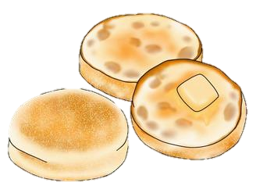  ACTIVITY: English Muffins | LEARNING OUTCOME: 1+3+4+5  ACTIVITY: Fruit Smoothies   | LEARNING OUTCOME: 1+3+4+5  ACTIVITY: Crumpets  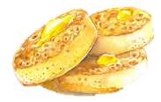 | LEARNING OUTCOME:1+3+4+5  ACTIVITY: Fruit Smoothies | LEARNING OUTCOME: 3+4+5    ACTIVITY: Pancakes
ACTIVITY 1 (7:00AM – 8:45AM) | LEARNING OUTCOME: 2+4+5    ACTIVITY: Word Search & Sudoku | LEARNING OUTCOME: 1+3+5    ACTIVITY: Outdoor Play: Sliding Doors | LEARNING OUTCOME: 1+4+5  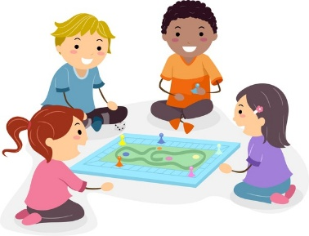  ACTIVITY: Board Game Extravaganza | LEARNING OUTCOME: 1+2+4+5    ACTIVITY: Children’s Meeting | LEARNING OUTCOME: 1+4    ACTIVITY: Drawing Corner
ACTIVITY 2  (8:45AM – 9:00AM) | LEARNING OUTCOME: 1+2+5    ACTIVITY: Storytime: Children’s Choice | LEARNING OUTCOME: 2+3+4+5  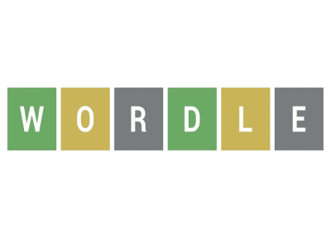  ACTIVITY: Literacy Time | LEARNING OUTCOME: 1+2+5  ACTIVITY: Storytime: Children’s Choice | LEARNING OUTCOME: 2+3+4+5  ACTIVITY: Literacy Time | LEARNING OUTCOME: 1+ 3+4+5  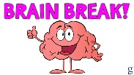  ACTIVITY: Children’s Choice Brain Break

