
FLASCA AFTER SCHOOL PROGRAM: TERM 4 WEEK 3
 | MONDAY | TUESDAY | WEDNESDAY | THURSDAY | FRIDAY
INDOORS (3:15PM – 5:00PM) | ACTIVITY: STEM Club: Surface Tension Experiment   | ACTIVITY: Arts & Craft Club: Suncatchers  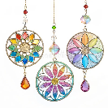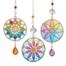 |   ACTIVITY: Halloween Escape Room | ACTIVITY: Performing Arts Club: Emotion charades   | ACTIVITY: Halloween Trick O Treat Bag Decorating  
GRASS (3:15PM – 5:00PM) | 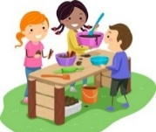  ACTIVITY: Sliding Doors & Mud Kitchen |     ACTIVITY: Soccer & Mud Kitchen |   ACTIVITY: Children’s Meeting & Capture the Flag | 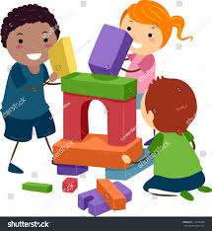  ACTIVITY: Soccer & FLASCA City Building | ACTIVITY: Halloween Trick O Treat Scavenger Hunt  
BBALL COURT (3.15-5.00PM | ACTIVITY: Pumpkin Oat Bars Cooking & Basketball   |   ACTIVITY Pumpkin Soup Oobleck & Gymnastics | 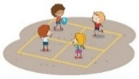  ACTIVITY: Halloween Spider Treat Cooking & Handball | 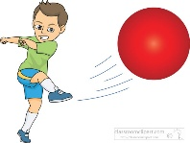  ACTIVITY: Kickball & Basketball |   ACTIVITY: Cooking Club: mummy sausage rolls
CLUB (3:15PM – 5:00PM) | STEM Club   | Arts & Craft Club  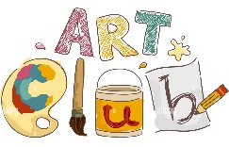 | FLASCA Children’s Council Meeting  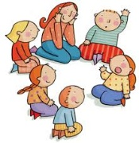 |   Performing Arts Club | Cooking Club  
EVENING (5:00PM – 6:00PM) |   ACTIVITY: CHILDREN’S CHOICE |   ACTIVITY: CHILDREN’S CHOICE | ACTIVITY: CHILDREN’S CHOICE   |   ACTIVITY: CHILDREN’S CHOICE | ACTIVITY: CHILDREN’S CHOICE

