FLASCA Excursion – Caneolands Orchards
(11/7/2025)
Risk Management Plan
Centre details
Company |  |  | Centre |  |  | FLASCA
Centre Operating Times |  | 7am – 6pm Monday to Friday
Address |  | 233 Bridge rd Forest Lodge 2037 |  | Water hazards? Yes/No  If yes, detail in risk assessment below.
Name of co-ordinator |  | Andrew Puletti
Contact number of Centre |  | Work Phone 9660 4334 |  | Mobile 0417 211 141
Average number of children centre |  | Incursions: 85  Excursions: 75 |  | Average number of educators |  | 10
 |  |  |  | Average parents/volunteers
Educator to child ratio, including whether this higher ratio is warranted? Please provide details. |  | Mainstream Ratio – 15 children: 1 educator  Waterplay Ratio – 7 children: 1 educator
Excursion checklist
□ First aid kit |  |  | □ List of adults participating in the excursion
□ List of children attending the excursion |  |  | □ Contact information for each adult
□ Contact information for each child |  |  | □ Mobile phone / other means of communicating with the service & emergency services
Medical information for each child |  |  | Other items, please list
Risk assessment
Method of Transport (Including Proposed Route)  Transport Procedures |  |  | Private bus directly from Forest Lodge Public School to Canoelands  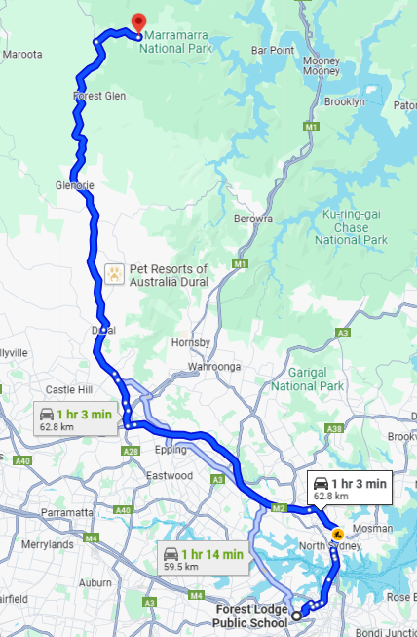  DEPARTING YOUR SERVICE AND GETTING ON THE BUS:  - Ensure children are wearing wrist bands and vests prior to departing the service.  - Children to line up in pairs, headcount is conducted and cross checked with the roll as children are leaving the service. Ensuring an Educator is at the front of the line, middle of the line and end of the line.  - Exit through front gates, line up on foot path outside front gates (on side closest to school, away from the road. Conduct headcount as students enter the bus (bus will arrive directly in front of school).  - Once all children are on the bus and seated a final headcount is completed.  ARRIVING AT THE VENUE AND GETTING OFF THE BUS:  - Once the bus has come to a complete stop in the designated drop off spot, the lead educator is to alight the bus first and ensure there is a safe space for children to line up at. Children are to be directed to this educator when alighting from bus. As the children are alighting the bus an Educator conducts a headcount and cross checks with the roll.  - Children are to line up in pairs along the path next to the bus stop.  - Once all children are off the bus, rollcall is conducted and cross checked with the roll.  - Once all children are off the bus the Responsible Person will ensure an Educator is at the front, middle and end of line.  - Ensure the last person off the bus checks all seats to ensure no children are left behind. If the luggage storage has been used check this for children. If there is a toilet on the bus check this for any children prior to leaving the bus.  - Ensure the last person off the bus is an educator, and they are to obtain the bus drivers direct contact number and confirm the collection time.  - Enter through the main entrance of Canoelands – headcount to be conducted and cross checked with the roll as children enter the venue. Ensuring the children are walking in their paired line with educators at the front, middle and end of the line.  DEPARTING THE VENUE AND GETTING ON THE BUS:  - Coordinator/RP to call the bus driver directly and confirm the bus is at the venue and the location prior to children leaving venue.  - Prior to leaving the venue, children are to line up in pairs and a Roll call is conducted and cross checked with the Kidsoft.  - Once at the front entrance of Canoelands a headcount is conducted as the children leave – ensuring there is an Educator at the front, middle and end of the line.  - Following walk towards the bus (parked directly in front of the entrance).  - Headcounts conducted and cross checked with the roll as children are getting on the bus.  - Headcount conducted and cross checked with the roll once all children are seated on the bus.  ARRIVING AT YOUR SERVICE AND GETTING OFF THE BUS:  - Once the bus has come to a complete stop, the lead educator is to alight the bus first and ensure there is a safe space for children to line up at.  - As the children are alighting the bus an Educator conducts a headcount and cross checks with the roll. Ensuring the last person off the bus is an educator.  - Ensure the last person off the bus checks all seats to ensure no children are left behind. If the luggage storage has been used check this for children. If there is a toilet on the bus check this for any children prior to leaving the bus.  - Ensure an Educator is at the front, middle and end of the line. Walk with children directly from bus to front gate (bus will be parked out front with no roads to cross).  - As children are entering the service a headcount is conducted and cross checked with the roll and all children are to be accounted for.
Activity | Hazard identified | Risk assessment  (use matrix) | Elimination/control measures |  | Who | When
Bus travel to and from venue | Traffic collision or breakdown | High | Reputable bus company with seatbelt-equipped buses; children seated with seatbelts fastened; headcounts before boarding and disembarking; first aid kits onboard. |  | Educators, Bus driver | Before and during travel
 | Child gets lost or left behind | High | Roll call and headcounts at every transition; designated educator per group; children wear FLASCA vests/wristbands with contact info. |  | Educators | Before, during travel
Kite making and flying | Poking injury from skewers; kite materials hazardous | Medium | Supervision during construction; safe scissors and child-friendly materials; educators assist with attaching skewers securely. |  | Educators, Children | During activity
 | Tripping while running with kites | Medium | Set boundaries for flying area; instruct children not to run with kites near others; adequate spacing outdoors. |  | Educators | During activity
Apple printing | Paint ingestion; slipping on spilled paint | Low | Use non-toxic paint; trays secured; wipe spills immediately; supervise closely to avoid paint near mouths. |  | Educators | During activity
Nature play (Orchard kitchen) | Contact with allergens, soil bacteria, or choking hazard | Medium | No tasting materials; supervise selection of safe items; handwashing immediately after; remind not to place objects in mouth. |  | Educators | During activity
Outdoor painting | Water spills, insect bites, sun exposure | Medium | Use stable cups; children seated while painting; apply sunscreen; ensure hats worn and shade used where possible. |  | Educators, Children | Before and during activity
Yoga | Strains from stretching, slipping on mats | Low | Demonstrate proper technique; non-slip mats used; calming environment; encourage self-paced participation. |  | Educators | During activity
Group reflection / journaling | Pencils used incorrectly; emotional distress when reflecting | Low | Supervise pencil use; support children who may feel unsure; provide alternate ways of expressing (drawing, talking). |  | Educators | During activity
Free play (outdoor areas) | Falls, collisions, sunburn, dehydration | Medium | Maintain supervision; enforce play boundaries; provide water breaks; ensure hats/sunscreen; rotate play groups if space is limited. |  | Educators | During activity
Toileting | Child separated from group, bathroom hazards | High | Children escorted in small groups; bathrooms checked by educator; headcounts pre/post; children to notify staff before/after use. |  | Educators | As needed throughout day
Lunch and afternoon tea | Food allergies, choking, sun exposure | Medium | Check allergy lists; supervise eating; ensure seated eating in shade; monitor hydration; reapply sunscreen as needed. |  | Educators | During meal times
General environmental risks | Weather conditions (heat, wind), insect bites | Medium | Monitor forecast; seek shelter/shade; hats and sunscreen required; insect repellent if needed; monitor for heat exhaustion or storm response protocol. |  | Educators | Throughout day
COVID-19 / Health protocols | Illness transmission | Medium-High | Enforce hygiene practices (handwashing, sanitiser); exclude unwell children; follow health authority guidance; PPE where needed. |  | Educators, Families | Throughout day
Emergency situations | Fire, lockdown, medical emergency | High | Emergency plans reviewed with staff; communication devices on hand; medication/medical plans accessible; first aid kits with educators. |  | Coordinator, Educators | Preparation and on the day
Child goes missing | Separation from group at orchard or venue | High | Regular headcounts; clear activity zones; assign children to small groups; ensure children are within sight; wristbands with emergency contacts worn. |  | Educators | Before, during, after

Plan prepared by | Full name: Logan Staight  Signature: LS  Role/Position: Responsible Person | Date: 20/06/2025
Prepared in consultation with | Full name: Demi Wu  Signature: DW  Role/Position: Assistant Coordinator | Date: 20/06/2025
Communicated to all relevant staff: | Yes
Risk assessment to be evaluated and reviewed on:
Reminder: Monitor the effectiveness of controls and change if necessary. Review the risk assessment if an incident or significant change occurs.

