+FLASCA Menu: Term 4 Week 3
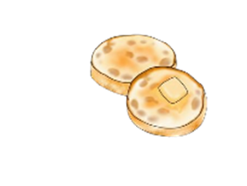


Breakfast:
Monday | Tuesday | Wednesday | Thursday | Friday
Toast with Jam, Honey, Vegemite, Butter  A selection of cereals  Fruit Smoothies | Toast with Jam, Honey, Vegemite, Butter  A selection of cereals  English Muffins | Toast with Jam, Honey, Vegemite, Butter  A selection of cereals  Oatmeal Bowls   | Toast with a either Jam, Honey, Vegemite, Butter  A selection of cereals  Fruit Smoothies | Toast with a either Jam, Honey, Vegemite, Butter  A selection of cereals  Pancakes

Afternoon Tea:
Monday | Tuesday | Wednesday | Thursday | Friday
Spaghetti and Meatballs  *Fresh fruit on the side*  - Spaghetti  - Passata  - Italian herb seasoning  - Beef Meatballs  - Cheese    Vegetarian & Gluten Free options available | Butter Chicken & Rice  *Fresh fruit on the side*  - Butter chicken sauce  - Chicken  - Rice  - Veggies    Vegetarian & Gluten Free options available | Yogurt Bowls  *Fresh fruit on the side*  - Yogurt – strawberry, vanilla, mango, blueberry  - Nut-free granola    Dairy Free & Gluten Free options available | Burritos  *Fresh fruit on the side*  - Minced beef and/or beans  - Cheese  - Veggies (tomatoes, lettuce and onions)  - Salsa  Vegetarian, Gluten Free & Dairy Free options available   | Pizza  *Fresh fruit on the side*  - Pizza base  - Pizza sauce  - Pepperoni  - Cheese  - Italian herb seasoning  Gluten Free options available  

Cruskits Nut-free Trail Mix Cheese & Crackers Nut-free Trail Mix Cruskits

