 | MONDAY | TUESDAY | WEDNESDAY | THURSDAY | FRIDAY
INDOORS (3:15PM – 5:00PM) | ACTIVITY: STEM Club: Binary Bracelets  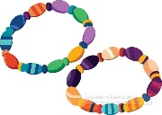 | ACTIVITY: Arts & Craft Club: Tissue Paper Stained Glass  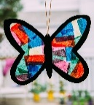 | ACTIVITY: Board Games Tournament  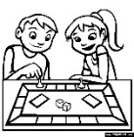 | ACTIVITY: DIY Ocean Drums  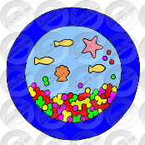 | 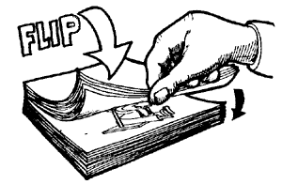  ACTIVITY: DIY Flip Book
GRASS (3:15PM – 5:00PM) | ACTIVITY: Ultimate Scissor Paper Rock (Suggested by Zac M.)    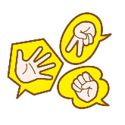 | ACTIVITY: Soccer & Reading Corner     | ACTIVITY: Children Council Meeting + Base Building  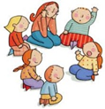  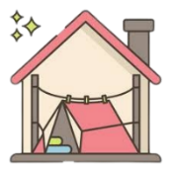 |   ACTIVITY: Follow The Leader + Yoga (Suggested by Georgia L.)  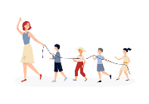 | ACTIVITY: Mud Kitchen + Lego Masters  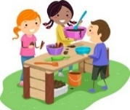  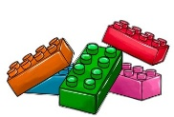
BBALL COURT (3.15-5.00PM | ACTIVITY: Cooking Activity: Rice Paper Rolls   | ACTIVITY: Basketball + Musical Chairs (Suggested by Saphira H.)    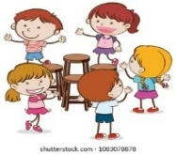 |     ACTIVITY: Handball Tournament (Suggested by Taylor M.) + PBL Zooper Doopers/Lactose-free Ice Cream! | 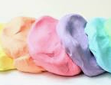    ACTIVITY: Performing Arts Club: Lip Sync Battle + Cloud Dough Making (Suggested by Jymarah S.) | 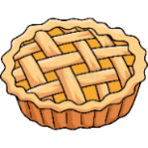  ACTIVITY: Cooking Club: Apple Pie Foldovers  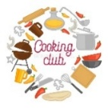
CLUB (3:15PM – 5:00PM) | STEM Club  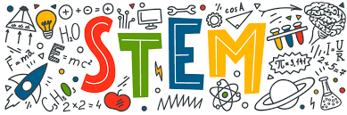 | Arts & Craft Club  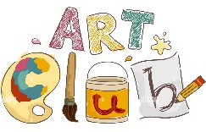 | FLASCA Children’s Council Meeting  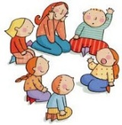 |   Performing Arts Club | Cooking Club  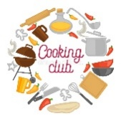
EVENING (5:00PM – 6:00PM) |   ACTIVITY: CHILDREN’S CHOICE |   ACTIVITY: CHILDREN’S CHOICE | ACTIVITY: CHILDREN’S CHOICE  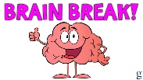 |   ACTIVITY: CHILDREN’S CHOICE | ACTIVITY: CHILDREN’S CHOICE

FLASCA AFTER SCHOOL PROGRAM: TERM 4 WEEK 6

