FLASCA Excursion – Golden Ridge Farm Day
(07/07/25)
Risk Management Plan
Centre details
Company |  |  | Centre |  |  | FLASCA
Centre Operating Times |  | 7am – 6pm Monday to Friday
Address |  | 233 Bridge rd Forest Lodge 2037 |  | Water hazards? Yes/No  If yes, detail in risk assessment below.
Name of co-ordinator |  | Demi Wu
Contact number of Centre |  | Work Phone 9660 4334 |  | Mobile 0417 211 141
Average number of children centre |  | Incursions: 85  Excursions: 75 |  | Average number of educators |  | 10
 |  |  |  | Average parents/volunteers
Educator to child ratio, including whether this higher ratio is warranted? Please provide details. |  | Mainstream Ratio – 15 children: 1 educator  Waterplay Ratio – 7 children: 1 educator
Excursion checklist
□ First aid kit |  |  | □ List of adults participating in the excursion
□ List of children attending the excursion |  |  | □ Contact information for each adult
□ Contact information for each child |  |  | □ Mobile phone / other means of communicating with the service & emergency services
Medical information for each child |  |  | Other items, please list
Risk assessment
Method of Transport (Including Proposed Route)  Transport Procedures |  |  | Private bus directly from Forest Lodge Public School to Golden Ridge Farm  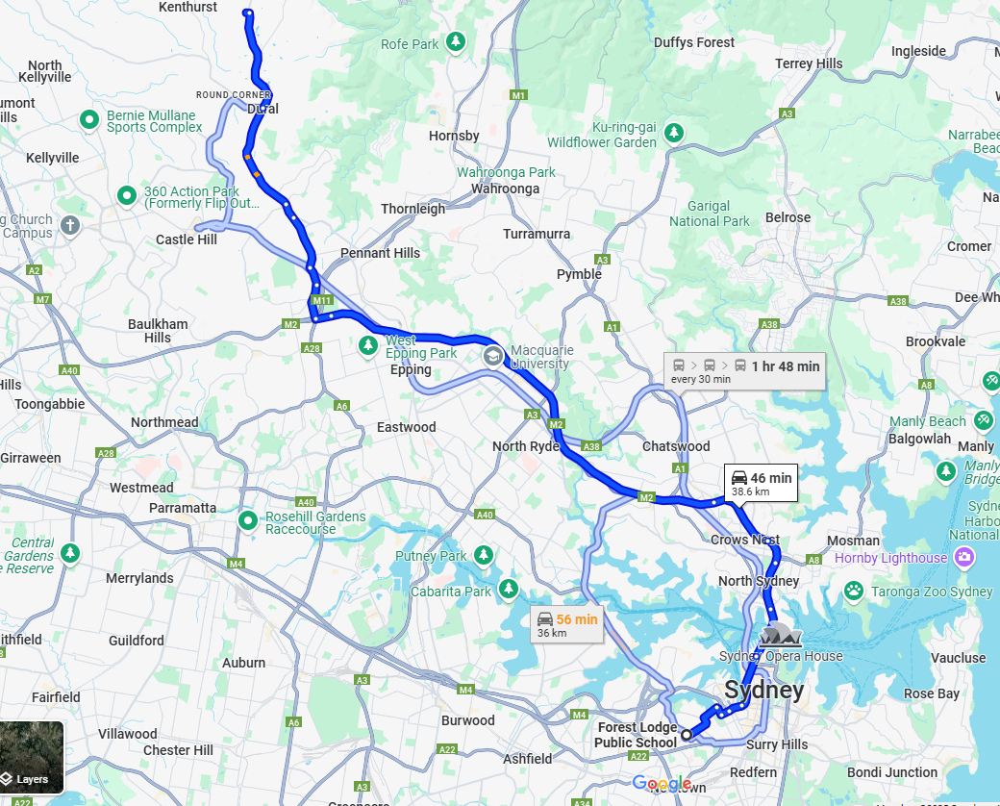  DEPARTING YOUR SERVICE AND GETTING ON THE BUS:  - Ensure children are wearing wrist bands and vests prior to departing the service.  - Children to line up in pairs, headcount is conducted and cross checked with the roll as children are leaving the service. Ensuring an Educator is at the front of the line, middle of the line and end of the line.  - Exit through front gates, line up on foot path outside front gates (on side closest to school, away from the road. Conduct headcount as students enter the bus (bus will arrive directly in front of school).  - Once all children are on the bus and seated a final headcount is completed.  ARRIVING AT THE VENUE AND GETTING OFF THE BUS:  - Once the bus has come to a complete stop in the designated drop off spot, the lead educator is to alight the bus first and ensure there is a safe space for children to line up at. Children are to be directed to this educator when alighting from bus. As the children are alighting the bus an Educator conducts a headcount and cross checks with the roll.  - Children are to line up in pairs along the path next to the bus stop.  - Once all children are off the bus, rollcall is conducted and cross checked with the roll.  - Once all children are off the bus the Responsible Person will ensure an Educator is at the front, middle and end of line.  - Ensure the last person off the bus checks all seats to ensure no children are left behind. If the luggage storage has been used check this for children. If there is a toilet on the bus check this for any children prior to leaving the bus.  - Ensure the last person off the bus is an educator, and they are to obtain the bus drivers direct contact number and confirm the collection time.  - Enter through the main entrance of the farm and enter the building – headcount to be conducted and cross checked with the roll as children enter the venue. Ensuring the children are walking in their paired line with educators at the front, middle and end of the line.  DEPARTING THE VENUE AND GETTING ON THE BUS:  - Coordinator/RP to call the bus driver directly and confirm the bus is at the venue and the location prior to children leaving venue.  - Prior to leaving the venue, children are to line up in pairs and a Roll call is conducted and cross checked with the Kidsoft.  - Once at the main door of the venue a headcount is conducted as the children leave – ensuring there is an Educator at the front, middle and end of the line.  - Following walk towards the bus (parked directly in front of farm).  - Headcounts conducted and cross checked with the roll as children are getting on the bus.  - Headcount conducted and cross checked with the roll once all children are seated on the bus.  ARRIVING AT YOUR SERVICE AND GETTING OFF THE BUS:  - Once the bus has come to a complete stop, the lead educator is to alight the bus first and ensure there is a safe space for children to line up at.  - As the children are alighting the bus an Educator conducts a headcount and cross checks with the roll. Ensuring the last person off the bus is an educator.  - Ensure the last person off the bus checks all seats to ensure no children are left behind. If the luggage storage has been used check this for children. If there is a toilet on the bus check this for any children prior to leaving the bus.  - Ensure an Educator is at the front, middle and end of the line. Walk with children directly from bus to front gate (bus will be parked out front with no roads to cross).  - As children are entering the service a headcount is conducted and cross checked with the roll and all children are to be accounted for.
Activity | Hazard identified | Risk assessment  (use matrix) | Elimination/control measures |  | Who | When
Walking around farm property | Slips, trips, falls on uneven ground | Likelihood: Possible | - Closed-toe shoes required  - Farm staff guide groups  - First aid kit on hand |  | Staff and educators | During farm tour
Travel to and from farm | Traffic accident | Unlikely | - Seatbelts on bus  - Headcount before departure and return  - Only accredited bus company used  - Staff supervision throughout journey |  | Bus driver and educators | Before and after farm excursion
Feeding or petting the animals | Animal bites scratches/  Allergic reactions | Possible | - Pre-visit allergy check  - Clear rules about animal interaction  - Supervised animal feeding  - Hand washing after contact |  | Staff and educators | During farm tour
Contact with animal droppings | infection | Possible | - Mandatory handwashing after contact  - No food/drink in animal areas  - Signage and education about hygiene |  | Staff and educators | During farm tour
Being in outdoor areas | Exposure to sun and dehydration | Likely | - Sunscreen and hats required  - Adequate water breaks  - Shaded rest areas |  | Staff and educators | During farm tour
Contact with plants or insects | Stings, bites, allergic reactions | Possible | - Pre-visit medical info reviewer  - Encourage long sleeves/pants  - First aid supplies and EpiPens (if applicable) |  | Staff and educators | During farm tour
Lost child | Child wanders off from group | Possible | - Buddy system  - Small, supervised groups  - Regular headcounts  - High-vis vests or hats for easy visibility |  | Staff and educators | During farm tour
Eating | Food allergies/chocking | Possible | - Allergen-free policy (or allergy management plan)  - Supervised eating  - Students sit down while eating |  | Staff and educators | Eating times
Toileting | Lack of Hygiene | Possible | - Toilets checked for cleanliness\  - Supervised access (depending on age group)  - Handwashing monitored |  | Educators | During whole day
Cow milking | Being kicked | Unlikely | - Supervision  - Cow is trained to stand in bale  - Leg tie used |  | Staff and educators | During farm tour
Bottle feeding | Allergy to milk | Unlikely | - Sit activity out  - Latex gloves can be used |  | Staff and educators | During farm tour

Plan prepared by | Full name: Andrew Puletti  Signature: AP  Role/Position: Educator | Date: 17/6/2025
Prepared in consultation with | Full name: Demi Wu  Signature: DW  Role/Position: Coordinator | Date: 17/6/2025
Communicated to all relevant staff: | Yes
Risk assessment to be evaluated and reviewed on: | 17/6/2025
Reminder: Monitor the effectiveness of controls and change if necessary. Review the risk assessment if an incident or significant change occurs.

