FLASCA Excursion – Taronga Zoo
14/7/2025
Risk Management Plan
Centre details
Company |  | FLASCA Inc. | Centre |  |  | FLASCA
Centre Operating Times |  | 7am – 6pm Monday to Friday
Address |  | 233 Bridge rd Forest Lodge 2037 |  | Water hazards? Yes/No  If yes, detail in risk assessment below.
Name of co-ordinator |  | Demi Wu
Contact number of Centre |  | Work Phone 9660 4334 |  | Mobile 0417 211 141
Average number of children centre |  | Incursions: 85  Excursions: 75 |  | Average number of educators |  | 10
 |  |  |  | Average parents/volunteers
Educator to child ratio, including whether this higher ratio is warranted? Please provide details. |  | Mainstream Ratio – 15 children: 1 educator  Waterplay Ratio – 7 children: 1 educator
Excursion checklist
□ First aid kit |  |  | □ List of adults participating in the excursion
□ List of children attending the excursion |  |  | □ Contact information for each adult
□ Contact information for each child |  |  | □ Mobile phone / other means of communicating with the service & emergency services
Medical information for each child |  |  | Other items, please list
Risk assessment
Method of Transport (Including Proposed Route)  Transport Procedures |  |  | Private bus directly from Forest Lodge Public School to Taronga Zoo  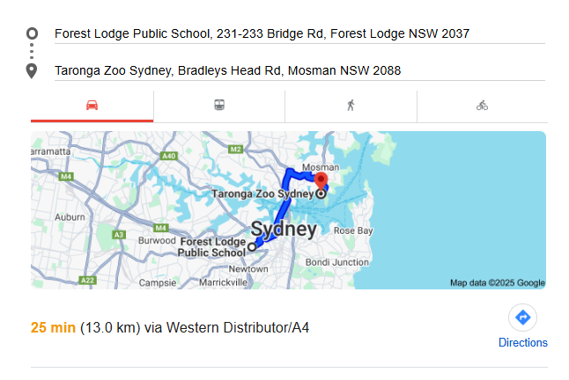  - DEPARTING YOUR SERVICE AND GETTING ON THE BUS:  - • Ensure children are wearing wrist bands and vests prior to departing the service.  - • Children to line up in pairs, headcount is conducted and cross checked with the roll as children are leaving the service. Ensuring an Educator is at the front of the line, middle of the line and end of the line.  - • Exit through front gates, line up on foot path outside front gates (on side closest to school, away from the road. Conduct headcount as students enter the bus (bus will arrive directly in front of school).  - • Once all children are on the bus and seated a final headcount is completed.  - ARRIVING AT THE VENUE AND GETTING OFF THE BUS:  - • Once the bus has come to a complete stop in the designated drop off spot, the lead educator is to alight the bus first and ensure there is a safe space for children to line up at. Children are to be directed to this educator when alighting from bus. As the children are alighting the bus an Educator conducts a headcount and cross checks with the roll.  - • Children are to line up in pairs along the path next to the bus stop.  - • Once all children are off the bus, rollcall is conducted and cross checked with the roll.  - • Once all children are off the bus the Responsible Person will ensure an Educator is at the front, middle and end of line.  - • Ensure the last person off the bus checks all seats to ensure no children are left behind. If the luggage storage has been used check this for children. If there is a toilet on the bus check this for any children prior to leaving the bus.  - • Ensure the last person off the bus is an educator, and they are to obtain the bus drivers direct contact number and confirm the collection time.  - • Enter through the main entrance of Canoelands – headcount to be conducted and cross checked with the roll as children enter the venue. Ensuring the children are walking in their paired line with educators at the front, middle and end of the line.  - DEPARTING THE VENUE AND GETTING ON THE BUS:  - • Coordinator/RP to call the bus driver directly and confirm the bus is at the venue and the location prior to children leaving venue.  - • Prior to leaving the venue, children are to line up in pairs and a Roll call is conducted and cross checked with the Kidsoft.  - • Once at the front entrance of Canoelands a headcount is conducted as the children leave – ensuring there is an Educator at the front, middle and end of the line.  - • Following walk towards the bus (parked directly in front of the entrance).  - • Headcounts conducted and cross checked with the roll as children are getting on the bus.  - • Headcount conducted and cross checked with the roll once all children are seated on the bus.  - ARRIVING AT YOUR SERVICE AND GETTING OFF THE BUS:  - • Once the bus has come to a complete stop, the lead educator is to alight the bus first and ensure there is a safe space for children to line up at.  - • As the children are alighting the bus an Educator conducts a headcount and cross checks with the roll. Ensuring the last person off the bus is an educator.  - • Ensure the last person off the bus checks all seats to ensure no children are left behind. If the luggage storage has been used check this for children. If there is a toilet on the bus check this for any children prior to leaving the bus.  - • Ensure an Educator is at the front, middle and end of the line. Walk with children directly from bus to front gate (bus will be parked out front with no roads to cross).  • As children are entering the service a headcount is conducted and cross checked with the roll and all children are to be accounted for.
Activity | Hazard identified | Risk assessment  (use matrix) | Elimination/control measures |  | Who | When
Bus travel to and from zoo | Traffic collision or bus breakdown | High | Use reputable bus company; ensure seat belts are worn; children seated throughout journey; first aid kits available; headcounts before/after boarding. |  | Educators, Bus driver | Before and during travel
 | Child gets lost or left behind | High | Wristbands with contact details; designated groups with assigned educators; roll call and headcounts at all transitions. |  | Educators | Before, during travel
Walking through zoo | Trips, slips, falls, sunburn, heat exhaustion | Medium | Enforce safe walking rules; regular water breaks; hats and sunscreen worn; appropriate footwear required; supervise bathroom visits. |  | Educators, Children | During excursion
 | Separation from group / missing child | High | Grouping with designated educator; high-visibility vests; regular roll calls and headcounts; children briefed on staying with group; walkie talkies used. |  | Educators | During excursion
 | Insect bites or animal contact | Medium | Educators to supervise closely; children instructed not to touch animals unless permitted; apply insect repellent if necessary. |  | Educators | During excursion
Zoo story time + drawing | Pencil misuse, distraction, emotional responses | Low | Supervise closely during drawing; provide alternate expression if children feel overwhelmed; assist children who need help articulating ideas. |  | Educators | During activity
Animal relay races | Falls, collisions, overheating | Medium | Set boundaries for race area; ensure children spaced and understand rules; encourage hydration; provide rest breaks; use soft surfaces. |  | Educators | During activity
Leaf/nature rubbing art | Allergic reaction to leaves or contact with insects | Medium | Use non-toxic and safe natural items; supervise collection process; check leaves for insects or dirt; handwashing before/after. |  | Educators | During activity
 | Pencils/crayons used improperly | Low | Age-appropriate materials; model correct usage; monitor closely. |  | Educators | During activity
Journaling & zoo reflection | Emotional sensitivity, incorrect pencil use | Low | Offer emotional support if reflections bring up discomfort; encourage alternative responses (drawing, talking); supervise tool use. |  | Educators | During activity
Build a Zoo (LEGO/STEM) | Choking hazard (small pieces), disputes over sharing | Medium | Use age-appropriate sets; monitor for proper use; facilitate cooperative play and resolution techniques; set clear expectations. |  | Educators | During activity
Animal yoga / calm corner | Slipping, overstretching, discomfort | Low | Use yoga mats or carpeted areas; gentle stretches only; allow children to opt out; demonstrate poses before children attempt them. |  | Educators | During activity
Lunch and snack breaks | Choking, allergies, dehydration, sun exposure | Medium | Check allergy plans; ensure seated eating in shaded areas; monitor water intake; enforce sunscreen and hat use; supervise hand hygiene. |  | Educators | During mealtimes
Toileting at zoo | Separation from group, public interaction | High | Escort in small groups; pre-check bathrooms for safety; frequent headcounts; children inform staff before/after; wait outside toilet blocks. |  | Educators | Throughout day
Weather exposure | Heat stress, UV exposure, rain | Medium | Check weather forecast; bring appropriate gear (hats, jackets); plan shaded rest breaks; provide sunscreen and water access. |  | Educators, Children | Before and during day
Illness | Virus transmission | Medium-High | Enforce hygiene (hand sanitiser, wipes); exclude unwell children/staff; follow health protocols; PPE if required; frequent handwashing routines. |  | Educators, Families | Throughout day
Emergency (Fire/Lockdown) | Evacuation required in zoo | High | Educators aware of zoo emergency protocols; maintain communication devices; follow staff instructions at zoo; stay in assigned groups. |  | Educators | If needed during excursion
General public interactions | Unsafe contact, crowding | Medium | Discuss safe behaviour with children beforehand; educators monitor surroundings; maintain ratio and awareness of other visitors; limit time in congested areas. |  | Educators | During excursion

Plan prepared by | Full name: Logan Staight  Signature: LS  Role/Position: Responsible Person | Date: 20/06/2025
Prepared in consultation with | Full name: Demi Wu  Signature: DW  Role/Position: Assistant Coordinator | Date: 20/06/2025
Communicated to all relevant staff: | Yes
Risk assessment to be evaluated and reviewed on:
Reminder: Monitor the effectiveness of controls and change if necessary. Review the risk assessment if an incident or significant change occurs.

