 | MONDAY | TUESDAY | WEDNESDAY | THURSDAY | FRIDAY
INDOORS (3:15PM – 5:00PM) | ACTIVITY: STEM Club: Dancing Raisins  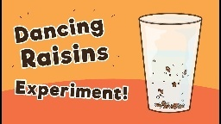 |   ACTIVITY: Arts & Craft Club: Paper Roll Characters |   ACTIVITY: Spy Invisible Ink Letters   | ACTIVITY: Balloon Rockets Race  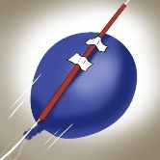 | 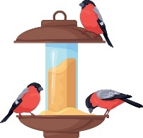  ACTIVITY: DIY Bird Feeder
GRASS (3:15PM – 5:00PM) | ACTIVITY: Gymnastics (Suggested by Georgia K.)  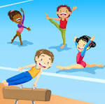 | ACTIVITY: Soccer & Reading Corner     | ACTIVITY: Children Council Meeting + Chain Tips  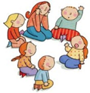   | ACTIVITY: Sliding doors (Suggested by Joshua T.) + AFL   | 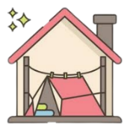  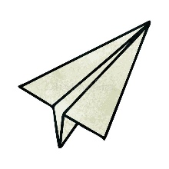  ACTIVITY: Paper plane Race+ Base Building. (Suggested by Saskia)
BBALL COURT (3.15-5.00PM | 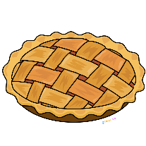  ACTIVITY: Cooking Activity: Thanksgiving Apple Pie | ACTIVITY: Basketball + Scramble (suggested by Saphira H.)     | 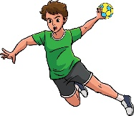  ACTIVITY: Handball Rallie (suggested by Zev) |     ACTIVITY: Performing Arts Club: Create a Commercial |   ACTIVITY: Cooking Club: Egg Free Chocolate Chip Cookies
CLUB (3:15PM – 5:00PM) | STEM Club   | Arts & Craft Club  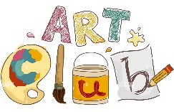 | FLASCA Children’s Council Meeting  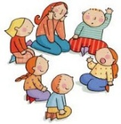 |   Performing Arts Club | Cooking Club  
EVENING (5:00PM – 6:00PM) |   ACTIVITY: CHILDREN’S CHOICE |   ACTIVITY: CHILDREN’S CHOICE | ACTIVITY: CHILDREN’S CHOICE   |   ACTIVITY: CHILDREN’S CHOICE | ACTIVITY: CHILDREN’S CHOICE

FLASCA AFTER SCHOOL PROGRAM: TERM 4 WEEK 7

