
FLASCA AFTER SCHOOL PROGRAM: TERM 4 WEEK 4
 | MONDAY | TUESDAY | WEDNESDAY | THURSDAY | FRIDAY
INDOORS (3:15PM – 5:00PM) | 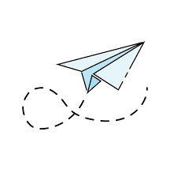  ACTIVITY: STEM Club: Paper Plane Challenge |   ACTIVITY: Arts & Craft Club: DIY Bookmarks | 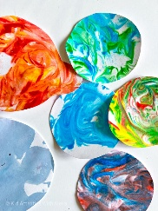  ACTIVITY: Shaving Foam Art | 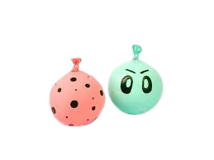  ACTIVITY: DIY Stress Balls | 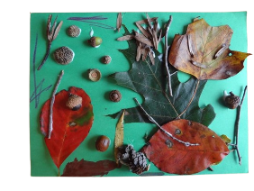  ACTIVITY: Nature Collage
GRASS (3:15PM – 5:00PM) | 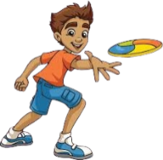  ACTIVITY: Ultimate Frisbee + Soccer   |   ACTIVITY: Capture the Flag | ACTIVITY: Children Council Meeting + Egg and Spoon Race  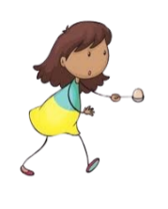  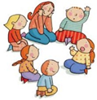 |   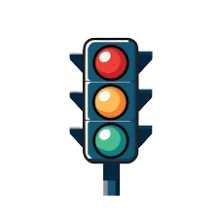  ACTIVITY: Performing Arts Club: Musical Statues + Red Light Green Light | ACTIVITY: Soccer + Base Building    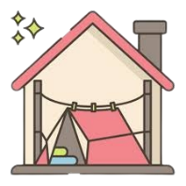
BBALL COURT (3.15-5.00PM |   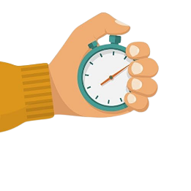  ACTIVITY: Beep Test + One Bounce |   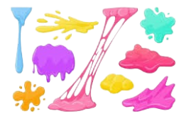  ACTIVITY: Playdough Making + Around the World | 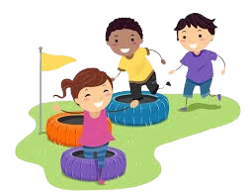  ACTIVITY: Obstacle Course |   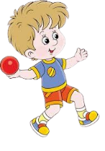  ACTIVITY: Wallball + Reading Corner |   ACTIVITY: Cooking Club: Chocolate Weetbix Slice
CLUB (3:15PM – 5:00PM) | STEM Club  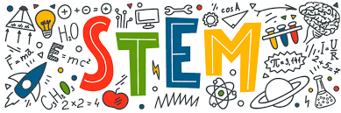 | Arts & Craft Club  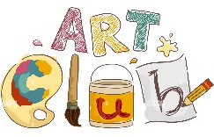 | FLASCA Children’s Council Meeting  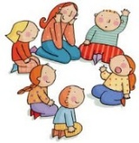 |   Performing Arts Club | Cooking Club  
EVENING (5:00PM – 6:00PM) |   ACTIVITY: CHILDREN’S CHOICE |   ACTIVITY: CHILDREN’S CHOICE | ACTIVITY: CHILDREN’S CHOICE  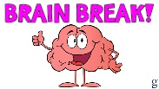 |   ACTIVITY: CHILDREN’S CHOICE | ACTIVITY: CHILDREN’S CHOICE

