FLASCA Menu: Term 4 Week 5

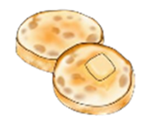

Breakfast:
Monday | Tuesday | Wednesday | Thursday | Friday
Toast with Jam, Honey, Vegemite, Butter  A selection of cereals  Fruit Smoothies | Toast with Jam, Honey, Vegemite, Butter  A selection of cereals    Crumpets | Toast with Jam, Honey, Vegemite, Butter  A selection of cereals  Fruit Smoothies | Toast with a either Jam, Honey, Vegemite, Butter  A selection of cereals  English Muffins | Toast with a either Jam, Honey, Vegemite, Butter  A selection of cereals  Pancakes



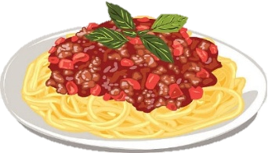
Afternoon Tea:
Monday | Tuesday | Wednesday | Thursday | Friday
Spaghetti Bolognese  *Fresh fruit and veggies on the side*  - Spaghetti  - Passata  - Minced beef  - Italian herbs seasoning  - Cheese  Vegetarian & Gluten Free options available | Yogurt Bowls  *Fresh fruit on the side*  - Vanilla, strawberry, blueberry and mango yogurt  - Nut-free granola    Vegetarian, Dairy Free & Gluten Free options available | Nachos  *Fresh fruit and veggies on the side*  - Tortilla chips  - Minced beef or beans  - Cheese  - Salsa, sour cream and/or guacamole  Vegetarian, Dairy Free & Gluten Free options available  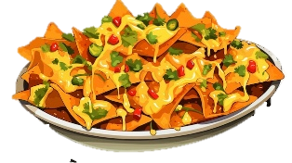 | Meatball Subs  *Fresh fruit and veggies on the side*  - Beef or vegan meatballs  - Bread rolls  - Cheese  - Passata  Vegetarian, Dairy Free & Gluten Free options available | Japanese Curry and Chicken Katsu  *Fresh fruit on the side*  - Japanese Curry  - Rice  - Carrots and potatoes  - Chicken katsu  Vegetarian & Gluten Free options available

Trail Mix Cruskits Cheese & Crackers Trail Mix Cruskits

