FLASCA Menu: 2026 Term 3, Week 1
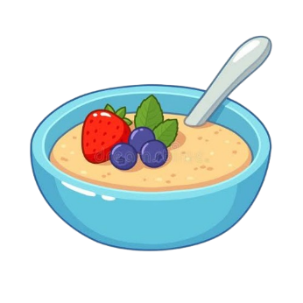
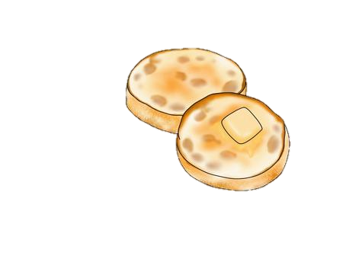
Breakfast:
Monday | Tuesday | Wednesday | Thursday | Friday
PUPIL FREE DAY | Toast with Jam, Honey, Vegemite, Butter, & a selection of cereals  English Muffins | Toast with Jam, Honey, Vegemite, Butter, & a selection of cereals  Oatmeal Bowls | Toast with Jam, Honey, Vegemite, Butter, & a selection of cereals    Fruit Smoothie | Toast with Jam, Honey, Vegemite, Butter, & a selection of cereals    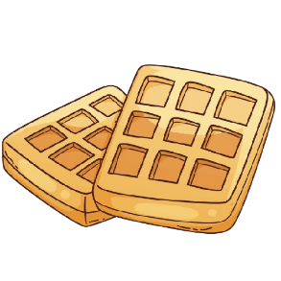  Waffles or Pancakes

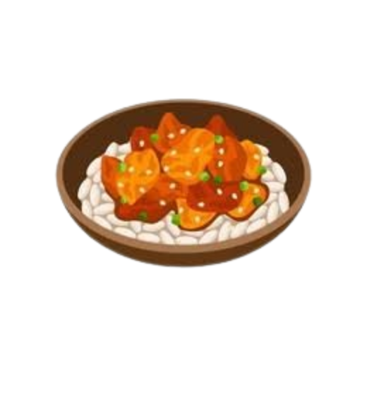
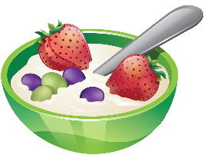
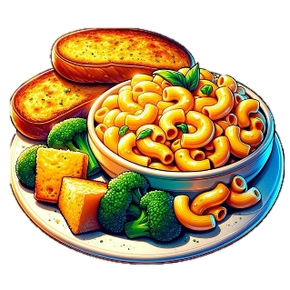
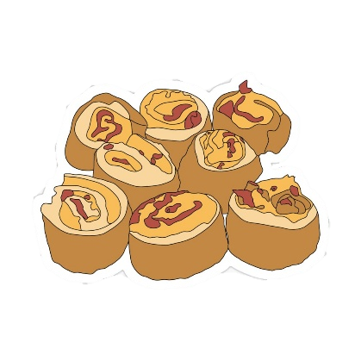
Afternoon Tea:
Monday | Tuesday | Wednesday | Thursday | Friday
PUPIL FREE DAY | Yogurt Bowls  - Mango, strawberry & vanilla yogurt  - Nut free granola  *Fresh fruit on the side*  Dairy Free & Gluten Free options available | Honey Soy Chicken & Rice  Suggested by Oliver W.  - Chicken breasts  - Rice  - Honey soy stir-fry sauce  - Rice  - Frozen veggie mix  *Fresh fruit and veggies on the side*  Vegetarian, dairy free & gluten free options available | Mac ‘n’ Cheese & Garlic Bread  Suggested by Yasmin H.  - Garlic bread loaves  - Cheese  - Pasta  *Fresh fruit & veggies on the side*  Vegetarian, Dairy Free & Gluten Free options available | Pizza Scrolls  Suggested by Cillian Y.  - Puff pastry  - Cheese  - Pepperoni  - Italian herb mix  *Fresh fruit and veggies on the side*  Vegetarian, dairy free & gluten free options available

Cheese & Crackers

Cruskits
Trail Mix
Trail Mix

