
FLASCA AFTER SCHOOL PROGRAM: TERM 2 WEEK 1
 | MONDAY | TUESDAY | WEDNESDAY | THURSDAY | FRIDAY
INDOORS (3:15PM – 5:00PM) | Vacation Care | Vacation Care | ACTIVITY: FLASCA VACATION MURAL   | ACTIVITY: ABORIGINAL DREAMTIME STORIES & ART  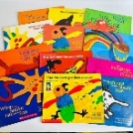 | 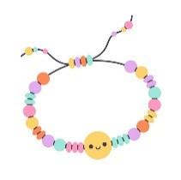  ACTIVITY: BRACELET MAKING
GRASS (3:15PM – 5:00PM) |  |  |     ACTIVITY: SOCCER & DRAWING CORNER | 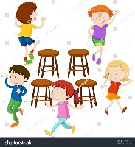    ACTIVITY: AFL & MUSICAL CHAIRS |   CTIVITY: SOCCER & DANCE PARTY
BBALL COURT (3.15-5.00PM |  |  |   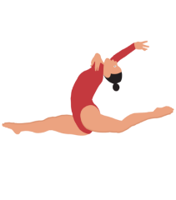  ACTIVITY: BASKETBALL & GYMNASTICS |   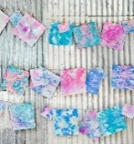  ACTIVITY: MARBLED MILK DYE PAPER & RELAXATION STATION | ACTIVITY: TIE DYE & COOKING CLUB    
CLUB (3:15PM – 5:00PM) |  |  | ACTIVITY: REVEALED IN WEEK 2!   | ACTIVITY: REVEALED IN WEEK 2!   | ACTIVITY: COOKING CLUB
EVENING (5:00PM – 6:00PM) |  |  |   ACTIVITY: CHILDREN’S CHOICE |   ACTIVITY: CHILDREN’S CHOICE | ACTIVITY: CHILDREN’S CHOICE  

