FLASCA Excursion – Jubilee Park
21/07/25
Risk Management Plan
Centre details
Company |  | FLASCA Inc. | Centre |  |  | FLASCA
Centre Operating Times |  | 7am – 6pm Monday to Friday
Address |  | 233 Bridge rd Forest Lodge 2037 |  | Water hazards? Yes/No  If yes, detail in risk assessment below.
Name of co-ordinator |  | Demi Wu
Contact number of Centre |  | Work Phone 9660 4334 |  | Mobile 0417 211 141
Average number of children centre |  | Incursions: 85  Excursions: 75 |  | Average number of educators |  | 10
 |  |  |  | Average parents/volunteers
Educator to child ratio, including whether this higher ratio is warranted? Please provide details. |  | Mainstream Ratio – 15 children: 1 educator  Waterplay Ratio – 7 children: 1 educator
Excursion checklist
□ First aid kit |  |  | □ List of adults participating in the excursion
□ List of children attending the excursion |  |  | □ Contact information for each adult
□ Contact information for each child |  |  | □ Mobile phone / other means of communicating with the service & emergency services
Medical information for each child |  |  | Other items, please list
Risk assessment
Method of Transport (Including Proposed Route)  Transport Procedures |  |  | 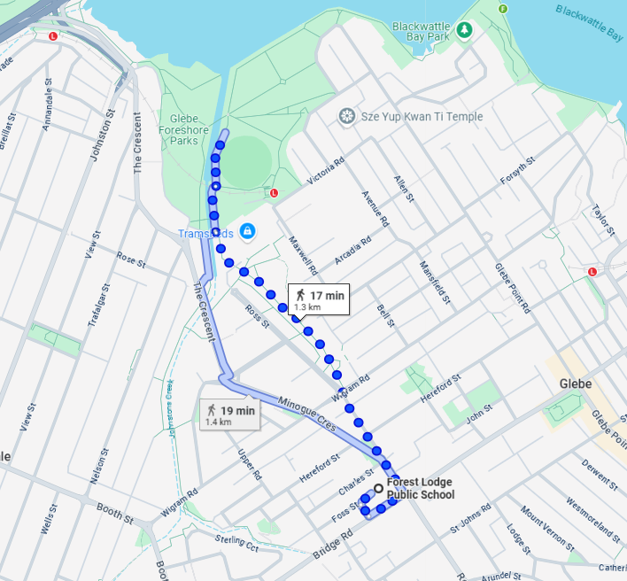  - Head south-west towards Foss St 41m  - Turn left onto Foss St 41 m  - Turn left onto Bridge Rd 110 m  - Turn left onto Ross St 300 m  - Turn right onto Wigram Rd 9 m  - Turn left Slight left 10 m  - Slight right 120 m  - Turn left  - Destination will be on the right  Commute time is approx. 17 minutes.  Children must remain on the pedestrian side of the footpath away from incoming traffic. Educators act as buffers.  Leaving the Centre  - Children are provided with sunscreen and FLASCA wristbands . Staff ensure everyone has drinking water available.  - A roll call is conducted prior to the children leaving the OOSH service grounds.  - The excursion coordinator is to ensure they know the number of children (total headcount).  - Each educator accompanies their group to the bathroom area with an educator waiting outside. The educator ensures all the children in their group are in their care before walking them to Bridge Rd.  Walking to the Venue  - We then walk to our destination with the educators working to ensure the children are with the group at all times. An educator is stationed at the front leading all the children to the destination. Another at the back to ensure all children are safe. Educators are encouraged to conduct their own group headcounts as we transition.  Entering and Leaving the Venue  - On arrival at our destination a roll call is conducted with another educator conducting a headcount of all children.  - Prior to exiting the venue another roll call & headcount is conducted.  Returning to the Centre  - Roll call & headcount is conducted.
Activity | Hazard identified | Risk assessment  (use matrix) | Elimination/control measures |  | Who | When
Walking to Venue | Slips, trips, falls, collisions | Moderate | - Organise children in 2 lines in close groups.  - Educators positioned at front, middle and ends of groups.  - Ensure each member of the group walks, not runs, and stays within sight of an educator  - Educators to choose flat surfaces to walk across and to warn children of potential trip hazards such as tree roots, leaves  - Supervise children carefully, ensuring that they leave adequate space between them and other children  - Children to be aware of their surroundings and to ‘give way’ to others  Ensure children walk carefully and avoid obstacles |  | Children and Educators | Before and During Activity.
 | Child may wander/ abscond | Moderate | - Constant head counts, and checking on children  - Educators to communicate with one another and the children  - Ensure each member of the group walks, not runs, and stays within sight of an educator  - Educators will have a walkie talkie to communicate to other staff whilst at the venue  - Educators will supervise tracks to ensure children do not leave the area. Educators positioned on the perimeter of the venue.  Educators will ensure children will not interact with the general public. They will check the bathrooms before the children enter, and will wait outside until the children are done. |  | Children and Educators | Before, During and After Activity.
 | Child may be struck by vehicles | Moderate | - Educators to stand watching incoming/outgoing traffic and stop vehicles if necessary.  Briefing on safe crossing prior to leaving FLASCA. |  | Educators | Before and During Activity.
 | Medical Emergencies | Moderate/High | - Let the staff know of the best ways to safely evacuate the children  - Have plans and medication accessible to be used for children with asthma and anaphylaxis conditions  - Educators will carry small first aid kits on them  Educators will have a walkie talkie to communicate to other staff whilst at the venue
Playing at the playground | Risk of injury | Moderate | - Escort children to age appropriate areas of the playground so they are not playing on equipment beyond their ability  - Ensure children know how to use equipment properly through explaining how to use unknown equipment to children  - Ensure children are being sensible on the equipment and are using it in an appropriate way through careful supervision.  - Ensure children do not walk/jump on walls/rocks nearby and are playing on the equipment the way it was designed to be played with  Educators to be prepared to help any children out who need it, ensuring they don’t fall |  | Educators and Children | During Activity
Using the toilets & hand washing | Children using toilets at the venue | High | - An Educator to check toilet areas for any hazards before children enter  - If the gender of that educator is not able to check the toilets. Send 2x older more responsible children to check whilst the educator waits right outside of toilet area  - Children to go in small groups of same gender  - Regular head counts and roll calls  - Educators to walk children in groups at a time and remain near toilet block area until children have finished  - Children to always communicate with educators about going to and from the toilets.  Excursion Coordinator to ensure antibacterial wipes and hand sanitiser is taken on all excursions and provided to children at times of washing hands. |  | All educators  All children | Whilst using toilets and hand washing areas
Eating lunch and recess | Risk of sunburn | Medium | Children to be seated in the shade while eating to reduce risk of sunburn. There is a shaded area on News Direct Rd. Sunscreen to be regularly reapplied. |  | Educators | On the day
 | Risk of allergies | Medium | Ensure that no people nearby are eating foods the child is allergic to, and ensure that any child with allergies is not given food that they are allergic to. |  | Educators | On the day
Environmental Impacts & Emergency Evacuation | Extreme Weather conditions (including heat stress, sun burn, storms, high winds), Fire / floods, emergency crisis/situatio | Medium | - Seek shade/shelter where appropriate.  Give time for children to be calm, safe and secure. |  | Educators & Children | Preparation before Excursion & During excursion
Water Hazards | Children tripping and falling into the harbour or wondering to the waters edge | Medium | - Ensure the children stay away from the water’s edge. Have educators standing as a boundary to the water  - Ensure safety discussion are had with the children prior to and during the excursion |  | Educators & Children | Preparation before Excursion & During excursion
Using the toilets & hand washing | Children using toilets at the venue | Medium | - The bathroom is shared with the Holey Moley centre next door. Set clear demarcations.  - Set clear rules and standards.  Constant head counts and monitoring children’s whereabouts. |  | Educators & Children | Whilst using toilets and hand washing areas
 | Missing child | High | - An Educator to check toilet areas for any hazards before children enter.  - If the gender of that educator is not able to check the toilets send 2x older more responsible children to check whilst the educator waits right outside of toilet area.  - Children to go in small groups of same gender.  - Regular head counts and roll calls.  - Educators to walk children in groups at a time and remain near toilet block area until children have finished.  Children to always communicate with educators about going to and from the toilets. |  | Educators and Children | Whilst using toilets and hand washing areas
 | Health & Hygiene | Medium | Excursion Coordinator to ensure antibacterial wipes and hand sanitiser is taken on all excursions and provided to children at times of washing hands. |  | Educators and Children | During the Excursion.
Encounters with the public/other children | Children engage in potentially unsafe interactions with the general public. | Moderate | - Encounters with the public are discussed with children before departure to ensure safety of all children.  Educators to supervise and monitor the area/children for any potential issues/hazards. |  | Educators and Children | During the Excursion.
Sun Protection & Dehydration | Sunburn / burns/ infections / illness Sun stroke, dehydration | Medium | - Check temperature & UV rating of the day at intervals the commencement of the day, lunch time and prior to 3pm.  - Ensure that Educators, volunteers & families are aware of our Sun Safety Policy.  - Ensure families pack hats for their children each day.  - Ensure children wear hats as necessary or stay under the shade. If UV is over 3 Provide shelter where necessary.  - Regularly ensure children have opportunity to get a drink of water.  - Ensure children still get opportunity of some sun exposure for Vitamin D levels (UV rating checked with this).  - Sunscreen will be applied throughout the day.  Ensure children have brought their water bottles. |  | The Coordinator, Parents/Families, Children Volunteers, and Educators. | Before leaving the centre & during the excursion.

Plan prepared by | Full name: Tahliya Sambrook  Signature: TS  Role/Position: Educator | Date: 2/07/2025
Prepared in consultation with | Full name: Demi Wu  Signature: DW  Role/Position: M.H | Date: 2/07/2025
Communicated to all relevant staff: | Yes/No
Risk assessment to be evaluated and reviewed on: | If this VC Program Activity is organised again.
Reminder: Monitor the effectiveness of controls and change if necessary. Review the risk assessment if an incident or significant change occurs.

