

FLASCA AFTER SCHOOL PROGRAM: TERM 4, WEEK 1
 | MONDAY | TUESDAY | WEDNESDAY | THURSDAY | FRIDAY
INDOORS (3:15PM – 5:00PM) | Last day of vacation care! | ACTIVITY: Make your own dragon  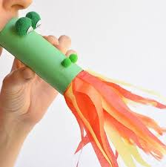 | ACTIVITY: Cupcake art  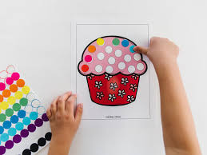 |   ACTIVITY: Dance Club: Showcase (FLASCA’s got talent) | ACTIVITY: Uno, cards, free drawing  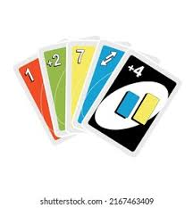
GRASS (3:15PM – 5:00PM) | Last day of vacation care! |     ACTIVITY: Soccer and Mindfulness/wellness corner | 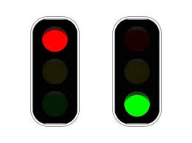    ACTIVITY: Red Light green light and Freeze |   ACTIVITY: Mud kitchen and soccer | ACTIVITY: Volley ball and musical chairs  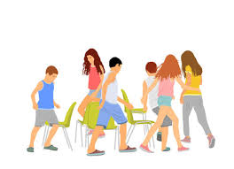  
BBALL COURT (3.15-5.00PM | Last day of vacation care! | ACTIVITY: Handball tournament by Zev K.) Gymnastics  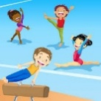 | ACTIVITY: 44 homes / Tips   |   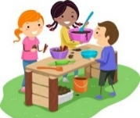  ACTIVITY: Chalk drawing and basketball | ACTIVITY: Cooking Club: Chocolate Rice Crispy Cakes  
CLUB (3:15PM – 5:00PM) | Last day of vacation care! | ACTIVITY: Arts & Design Club  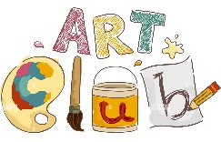 | ACTIVITY: Music Club | ACTIVITY: Dance Club   | ACTIVITY: Cooking Club  

