
FLASCA AFTER SCHOOL PROGRAM: TERM 4 WEEK 2
 | MONDAY | TUESDAY | WEDNESDAY | THURSDAY | FRIDAY
INDOORS (3:15PM – 5:00PM) | ACTIVITY: STEM Club: Magic Milk!  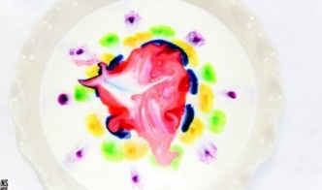 | ACTIVITY: Arts & Craft Club: Halloween Popsicle Stick Crafts (Jack-O’-Lantern)  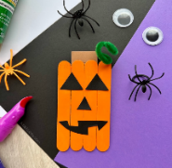 | 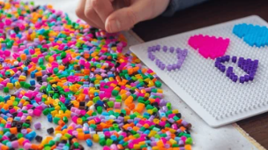  ACTIVITY: Arts: Hama Beading! |   ACTIVITY: Performing Arts Club: Charades! | 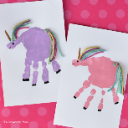  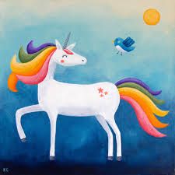  ACTIVITY: Unicorn Painting
GRASS (3:15PM – 5:00PM) |   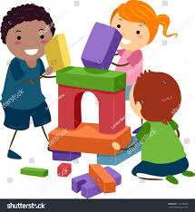  ACTIVITY: Soccer & FLASCA Base Equipment City Challenge | 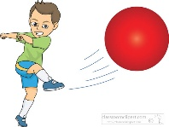    ACTIVITY: Kickball & Reading Corner |   ACTIVITY: Aboriginal Rock Art Storytelling & Soccer |   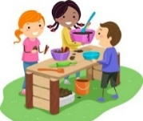  ACTIVITY: Sliding Doors & Mud Kitchen | ACTIVITY: Scramble
BBALL COURT (3.15-5.00PM |   ACTIVITY: Gymnastics & Chalk Drawing   |   ACTIVITY Basketball & Playdough Making  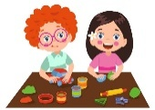 | 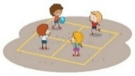  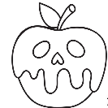  ACTIVITY: Halloween Stencil Painting & Handball Tournament | 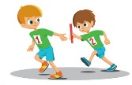  ACTIVITY: FLASCA Relay Race & Basketball |   ACTIVITY: Double Dutch & Cooking Club: Rolled Sugar Cookies to decorate!  
CLUB (3:15PM – 5:00PM) | STEM Club  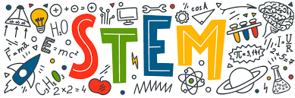 | Arts & Craft Club  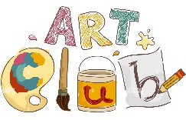 | FLASCA Children’s Council Meeting |   Performing Arts Club | Cooking Club  
EVENING (5:00PM – 6:00PM) | ACTIVITY: CHILDREN’S CHOICE |   ACTIVITY: CHILDREN’S CHOICE | ACTIVITY: CHILDREN’S CHOICE  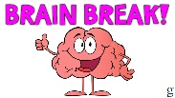 |   ACTIVITY: CHILDREN’S CHOICE | ACTIVITY: CHILDREN’S CHOICE

