FLASCA Excursion – Ultimate Family Entertainment Centre
(15/7/2025)
Risk Management Plan:
Centre details
Company |  |  | Centre |  |  | FLASCA
Centre Operating Times |  | 7am 6pm Monday to Friday
Address |  | 233 Bridge rd Forest Lodge 2037 |  | Water hazards? Yes/No  If yes, detail in risk assessment below.
Name of co-ordinator |  | Demi Wu
Contact number of Centre |  | Work Phone 9660 4334 |  | Mobile 0417 211 141
Average number of children centre |  | Incursions: 80  Excursions: 75 |  | Average number of educators |  | 10
 |  |  |  | Average parents/volunteers
Educator to child ratio, including whether this higher ratio is warranted? Please provide details. |  | Mainstream Ratio – 15 children: 1 educator  Waterplay Ratio – 7 children: 1 educator
Excursion checklist
□ First aid kit |  |  | □ List of adults participating in the excursion
□ List of children attending the excursion |  |  | □ Contact information for each adult
□ Contact information for each child |  |  | □ Mobile phone / other means of communicating with the service & emergency services
Medical information for each child |  |  | Other items, please list
Risk assessment
Method of Transport (Including Proposed Route)  Transport Procedures |  |  | 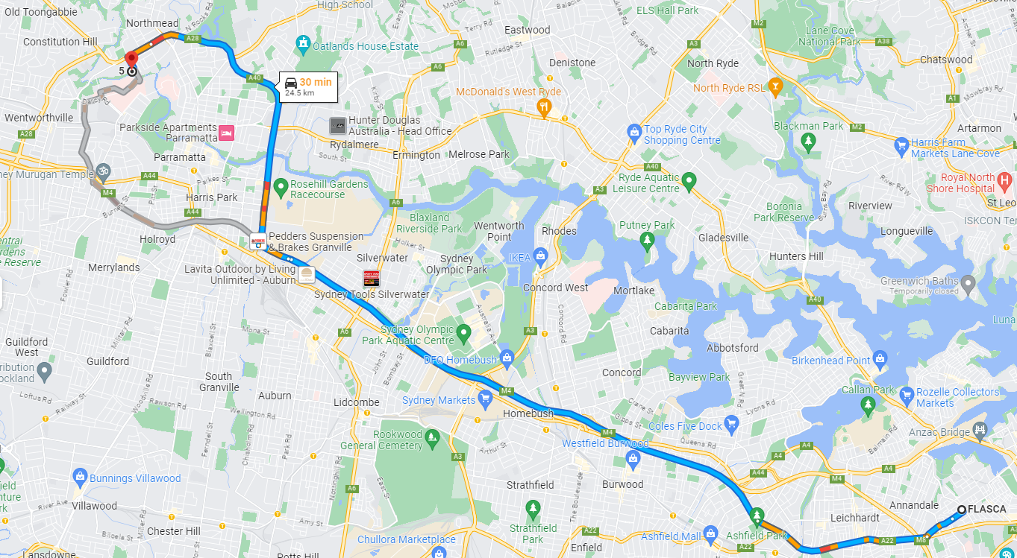  Catch a hired bus from Flasca in Forest Lodge to Ultimate Family Entertainment Centre in Northmead.  - Take Pyrmont Bridge Rd to Great Western Hwy/Parramatta Rd/A22 in Annandale  - Continue on Great Western Hwy/Parramatta Rd. Take M4 and James Ruse Dr to Redbank Rd in Northmead  - Turn left onto Redbank Rd  Commute time approximates to 30 minutes.  Leaving the Centre  - Children are provided with sunscreen and FLASCA wristbands . Staff ensure everyone has drinking water available.  - A roll call is conducted prior to the children leaving the OOSH service grounds.  - The excursion coordinator is to ensure they know the number of children (total headcount).  - Each educator accompanies their group to the bathroom area with an educator waiting outside. The educator ensures all the children in their group are in their care before walking them to Bridge Rd.  Walking to the Venue  - We then walk to our destination with the educators working to ensure the children are with the group at all times. An educator is stationed at the front leading all the children to the destination. Another at the back to ensure all children are safe. Educators are encouraged to conduct their own group headcounts as we transition.  Entering and Leaving the Venue  - On arrival at our destination a roll call is conducted with another educator conducting a headcount of all children.  - Prior to exiting the venue another roll call & headcount is conducted.  Entering and Exiting the Bus  - We then walk to our destination with the educators working to ensure the children are with the group at all times. An educator is stationed at the front leading all the children to the destination. Another at the back to ensure all children are safe. Educators are encouraged to conduct their own group headcounts as we transition.  Returning to the Centre  - Roll call & headcount is conducted.
Activity | Hazard identified | Risk assessment  (use matrix) | Elimination/control measures |  | Who | When
Entering and Exiting play centre | Lost child | Moderate | - Children to use buddy system.  - All children will wear OOSH band hi-vis vest with centre number  - Staff allocated group of children for the day |  | Children and Educators | Before and During Activity.
 | Tripping, falling, collisions with others | Moderate | - Children are strictly instructed not to run. They are to be reminded of the crowded interior environment. |  | Children and Educators | Before and During Activity.
Playing on the indoor equipment  - Climbing frames/wall  - Trampolines  - Slides  - Foam pits | Child may trip/fall on equipment  Unsafe/ Faulty Equipment | Moderate | - Ensure staff at Ultimate Family Entertainment explain the rules/guidelines of appropriate behaviour  - Group discussion with children about safety and appropriate behaviour prior to excursion  - Actively supervise children at all times.  - staff to spread out throughout the centre to ensure all areas are supervised diligently  - First aid kit available  - All managerial staff are trained in first aid  - We expect Family Entertainment centre to abide by their regulations and standards and ensure equipment is upkept. |  | Children and Educators | Before and During Activity.
Travel on bus from Forest Lodge Flasca Centre to Ultimate Family Entertainment Centre | Children injured in the commuting process. | Medium | - Educators to initiate conversation with bus driver to ensure bus driver is not intoxicated or otherwise incapacitated from driving a bus.  - Children are instructed to wear seatbelts and Educators are to ensure this is done.  - If the condition of the bus itself is considered dangerous we will not go ahead with the excursion.  - Ensure children are sitting in their seats at all times, and are not distracting to the bus driver. Nobody is to move around the bus while the bus is in motion.  - Road accident en route to venue: If the accident is not serious: On regular road keep children safe by staying on the bus if it is safe to do so. If not, move children to a safe location on footpath or grass area that is safe and protected from oncoming traffic. Contact centre and Manager as soon as possible.  - If the accident is serious: Move those able to walk away from the scene of the accident to a safe location. This will need to be assessed at the time. Assess casualties and administer first aid as best you can until emergency help arrives. Call ‘000’ and cooperate with emergency services at all times. At least one Educator (if possible) to accompany children to hospital until parents arrive. Contact centre and Manager as soon as possible. – Educator at service will begin contacting parents.  - Mechanical Breakdown: Keep children safe by staying on the bus if it is safe to do so. If not move children to a safe location protected from oncoming traffic, sun and heat. Educators to supervise children to avoid danger until problem is fixed or replacement bus arrives |  | Educator/s Supervising Staff Members | On travel & arrival to the venue
Disembarking from Bus into Venue | Slips, trips, falls, collisions | Medium | - Walk children, 2 lines in close groups.  - Educators positioned at front, middle and ends of groups. |  | Educators | During Excursion.
 | Child may wander/ abscond | Medium | - Constant head counts, and checking on children.  - Educators to communicate with one another and the children.  - Ratio of 1:15 to ensure children’s safety. |  | Educators | During Excursion.
 | Child may be struck by vehicles | Medium | - Request bus driver drop us in a safe out of the way place in the carpark. Educators to stand watching incoming/outgoing traffic and stop vehicles if necessary. Educators to usher children to the nearest safe (grass) area for headcounts to ensure children are safe. |  | Educators | As children exit the vehicle.
 | Entering the Venue | Medium | - Maintain children close in groups.  - Close supervision.  - Educators encourage children to listen and implement appropriate behaviours. |  | All Educators  All Children | Whilst entering the venue.
 | Venue transitioning. | Medium | - The carparks Ultimate Family Entertainment Centre have a light flow of traffic. It is contingent on Educators to ensure that children are abstaining from using this area.  - Educators to maintain close supervision of children as they enter the venue. |  | All Educators  All Children | Whilst entering the venue.
Walking Around the Facilities | Trips, slips, falls, injuries, illness | Medium | - An educator to lead each group as per child:educator ratio.  - Ensure each member of the group walks, not runs, and stays within sight of an educator.  - Educators to choose flat surfaces to walk across and to warn children of potential trip hazards such as tree roots, leaves. |  | All educators  All children | Whilst walking around the premises.
 | Risk of collision while walking | Medium | - Supervise children carefully, ensuring that they leave adequate space between them and other children. |  | All educators | On the day
 | Children passing one other | Medium | - Children to be aware of their surroundings and to ‘give way’ to others. |  | All educators and children | On the day
 | Getting hands/feet caught in and under materials | Medium | - Ensure children walk carefully and avoid obstacles. |  | All educators and children | On the day
 | Risk of needing to evacuate the area due to fire etc. and children not knowing where to go | Medium | - Let the staff know of the best ways to safely evacuate the children.  - Excursion supervisor is familiar with the evacuation plans of Ultimate Family Entertainment Centre. |  | Educators | On the day
 | Medical emergencies | High | - Have plans and medication accessible to be used for children with asthma and anaphylaxis conditions. |  | Educators | On the day
 | First aid required | High | - Excursion Supervisor (floating) carries a medical bag |  | Educators | On the day
Eating lunch and recess | Risk of sunburn | Medium | - Children to be seated in the shade while eating to reduce risk of sunburn. There is a shaded area on News Direct Rd. Sunscreen to be regularly reapplied. |  | Educators | On the day
 | Risk of allergies | Medium | - Ensure that no people nearby are eating foods the child is allergic to, and ensure that any child with allergies is not given food that they are allergic to. |  | Educators | On the day
Environmental Impacts & Emergency Evacuation | Extreme Weather conditions (including heat stress, sun burn, storms, high winds), Fire / floods, emergency crisis/situation | Medium | - Seek shade/shelter where appropriate.  - Give time for children to be calm, safe and secure. |  | Educators & Children | Preparation before Excursion & During excursion
Using the toilets & hand washing | Children using toilets at the venue | Medium | - Set clear demarcations.  - Set clear rules and standards.  - Constant head counts and monitoring children’s whereabouts. |  | Educators & Children | Whilst using toilets and hand washing areas
 | Missing child | High | - An Educator to check toilet areas for any hazards before children enter.  - If the gender of that educator is not able to check the toilets send 2x older more responsible children to check whilst the educator waits right outside of toilet area.  - Children to go in small groups of same gender.  - Regular head counts and roll calls.  - Educators to walk children in groups at a time and remain near toilet block area until children have finished.  - Children to always communicate with educators about going to and from the toilets. |  | Educators and Children | Whilst using toilets and hand washing areas
 | Health & Hygiene | Medium | - Excursion Coordinator to ensure antibacterial wipes and hand sanitiser is taken on all excursions and provided to children at times of washing hands. |  | Educators and Children | During the Excursion.
Encounters with the public/other children | Children engage in potentially unsafe interactions with the general public. | Moderate | - Encounters with the public are discussed with children before departure to ensure safety of all children.  - Educators to supervise and monitor the area/children for any potential issues/hazards. |  | Educators and Children | During the Excursion.
Sun Protection & Dehydration | Sunburn / burns/ infections / illness Sun stroke, dehydration | Medium | - Check temperature & UV rating of the day at intervals the commencement of the day, lunch time and prior to 3pm.  - Ensure that Educators, volunteers & families are aware of our Sun Safety Policy.  - Ensure families pack hats for their children each day.  - Ensure children wear hats as necessary or stay under the shade. If UV is over 3 Provide shelter where necessary.  - Regularly ensure children have opportunity to get a drink of water.  - Ensure children still get opportunity of some sun exposure for Vitamin D levels (UV rating checked with this).  - Sunscreen will be applied throughout the day.  - Ensure children have brought their water bottles. |  | The Coordinator, Parents/Families, Children Volunteers, and Educators. | Before leaving the centre & during the excursion.
Mini obstacle course | Trips, injuries, falls, head knocks, collisions | Medium | - Educator to be always supervising to avoid any dangerous obstacles being created.  - Ensure cones clearly show where the obstacles are.  - Students will be lined up and proceed on the course one at a time |  | Educators & Children | During the activity
Draw your ultimate playground | Sharp pencil pokes, paper cuts | Mild | - Children to be supervised to avoid any harmful play with pencils.  - Paper will be given individually. |  | Educators & Children | During the activity
Drama games – Act it out | Collisions, trips, falls, bumping into furniture, injuries | Medium | - Children will be given a clear safe space to commence the activity.  - Children watching are to sit or stand with an appropriate distance from the children acting. |  | Children | During the activity
Collaborative chalk mural | Grazes, cuts, scratches, trips | Mild | - Children will be set their own area to avoid collision or trips  - Mats will be provided to avoid grazes from the concrete. |  | Children | During the activity
Team challenges | Trips, injuries, falls, cuts or grazes, collisions | Medium | - Supervision and clear instructions to run games safely and smoothly  - Outline the playing area to avoid trips or hazards |  | Educators & Children | During the activity

Plan prepared by | Full name: Andrew Puletti  Signature: AP  Role/Position: Educator | Date: 30/6/2025 | Plan prepared by: | Co | James Willoughby
Prepared in consultation with: | Full Name: Demi Wu  Signature: DW  Role/position: Coordinator | Date: 30/6/2025 | Prepared in consultation with: | Centre Co-ordinator | Patrick Power
Communicated to all relevant staff: | Yes |  | Communicated to: | Regional Manager | Alex Grimaldi
Risk assessment to be evaluated and reviewed on: | If this VC Program Activity is organised again. |  | Venue and safety information reviewed and attached | Yes / No  Comment if needed:
Reminder: Monitor the effectiveness of controls and change if necessary. Review the risk assessment if an incident or significant change occurs. |  |  | Reminder: Monitor the effectiveness of controls and change if necessary. Review the risk assessment if an incident or significant change occurs.

